R

SUN uNIversity database project

BY ALLAN FARAI MAKWEMBERE & ABDULGAFFAR YAHAYA IBRAHIM

# Business Rules

**Brief:** A computerised system for recording module results and enrolled courses for students.

For the data to be carefully monitored and specific, we agreed upon a few business rules that would ensure efficiency in the database. These were drawn from the assessment brief.

* A Pass is 40%
* Students can take many modules.
* Each component has weighting .e.g exam is 10% of total mark.
* If one component is failed, the mark is capped to 39% and a student must take a resit on the part they failed.
* Modules to have no more than 2 components.
* Semesters can be: SEM1, SEM2, Year or Resit
* Modules can be assessed in components, .e.g 4CS3240 has Coursework and Exam.

ERD DIAGRAM

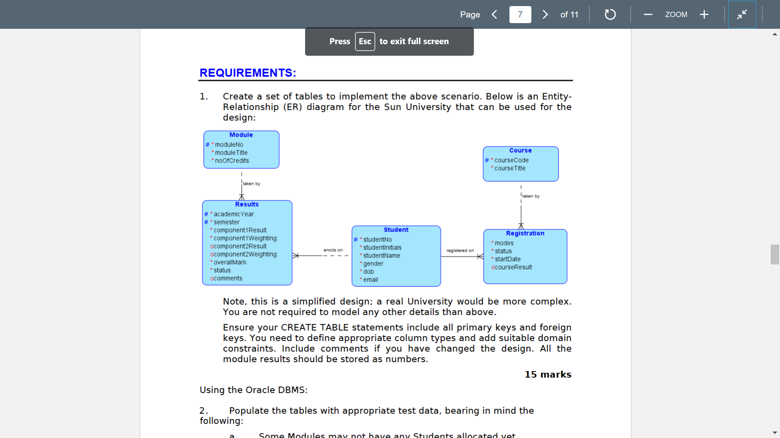

# ASSUMPTIONS

* Semester to have a domain constraint.
* Results has a composite key of AcademicYear and Semester.
* Email to be based on the outlook University account (…@sun.ac.uk).
* Overall mark requires a trigger that checks that the mark is correct against the weightings and results of the components.
* We will be using both SQL developer and SQL*PLUS.

# Table Headings (In order of creation)

**MODULE (moduleNo, moduleTitle, noOfCredits)**

**STUDENT (studentNo, studentInitials, studentName, gender, dob, email)**

**COURSE (courseCode, courseTitle)**

**RESULTS (AcademicYear, Semester, *moduleNo, *studentNo, component1Result, component1Weighting, component2Result, component2Result, component2Weighting, overallMark, status, comments)**

**REGISTRATION (*studentNo, *courseCode, modes, status, startDate, courseResult)**

# TABLE CREATION

SQL:

CREATE TABLE MODULE(

moduleNo VARCHAR2(6) primary key,

moduleTitle VARCHAR2(25) NOT NULL,

noOfCredits NUMBER(3) NOT NULL

);

CREATE TABLE STUDENT(

studentNo NUMBER(7) PRIMARY KEY,

studentInitials VARCHAR2(3) NOT NULL,

studentName VARCHAR2(25) NOT NULL,

gender VARCHAR2(1) NOT NULL check ((gender like 'F' OR gender like 'M')),

dob DATE NOT NULL,

email VARCHAR(25) NOT NULL CHECK (email like '%@sun.ac.uk')

);

CREATE TABLE COURSE(

courseCode VARCHAR(5) PRIMARY KEY,

courseTitle VARCHAR2(25)

);

CREATE TABLE RESULTS(

AcademicYear VARCHAR(7),

Semester VARCHAR(4) CHECK (Semester like 'SEM%' or Semester = 'Resit'),

moduleNo VARCHAR2(6),

studentNo NUMBER(7),

component1Result Number(3) Not Null CHECK ((component1Result < 100) or (component1Result = 100)),

component1Weighting Number(3) Not Null CHECK ((component1Weighting < 100) or (component1Weighting = 100)),

component2Result Number(3) CHECK ((component2Result < 100) or (component2Result = 100)),

component2Weighting Number(3) CHECK (component2Weighting < 100),

overallMark Number(3) NOT NULL,

status VARCHAR(5) NOT NULL,

comments VARCHAR(20),

FOREIGN KEY (moduleNo) REFERENCES MODULE(moduleNo),

FOREIGN KEY (studentNo) REFERENCES STUDENT(studentNo),

Constraint Comp_key PRIMARY KEY (Semester, AcademicYear, moduleNo, studentNo)

);

CREATE TABLE REGISTRATION(

studentNo NUMBER(7),

courseCode VARCHAR(5),

modes VARCHAR(2) NOT NULL,

status VARCHAR(1) NOT NULL,

startDate DATE NOT NULL,

courseResult VARCHAR(25),

FOREIGN KEY (studentNo) REFERENCES STUDENT(studentNo),

FOREIGN KEY (courseCode) REFERENCES COURSE(courseCode),

Constraint Composite PRIMARY KEY (studentNo, courseCode)

);

We created the tables using Oracle SQL*PLUS. We will mention the unique constraints we used for each column (we will not repeat what they are if they appear in more than one table). The constraint we used are PRIMARY KEY, NOT NULL, CHECK, FOREIGN KEY, and precision specifiers for the data types like the one below for the module table, VARCHAR2(6).

**Module Table:**

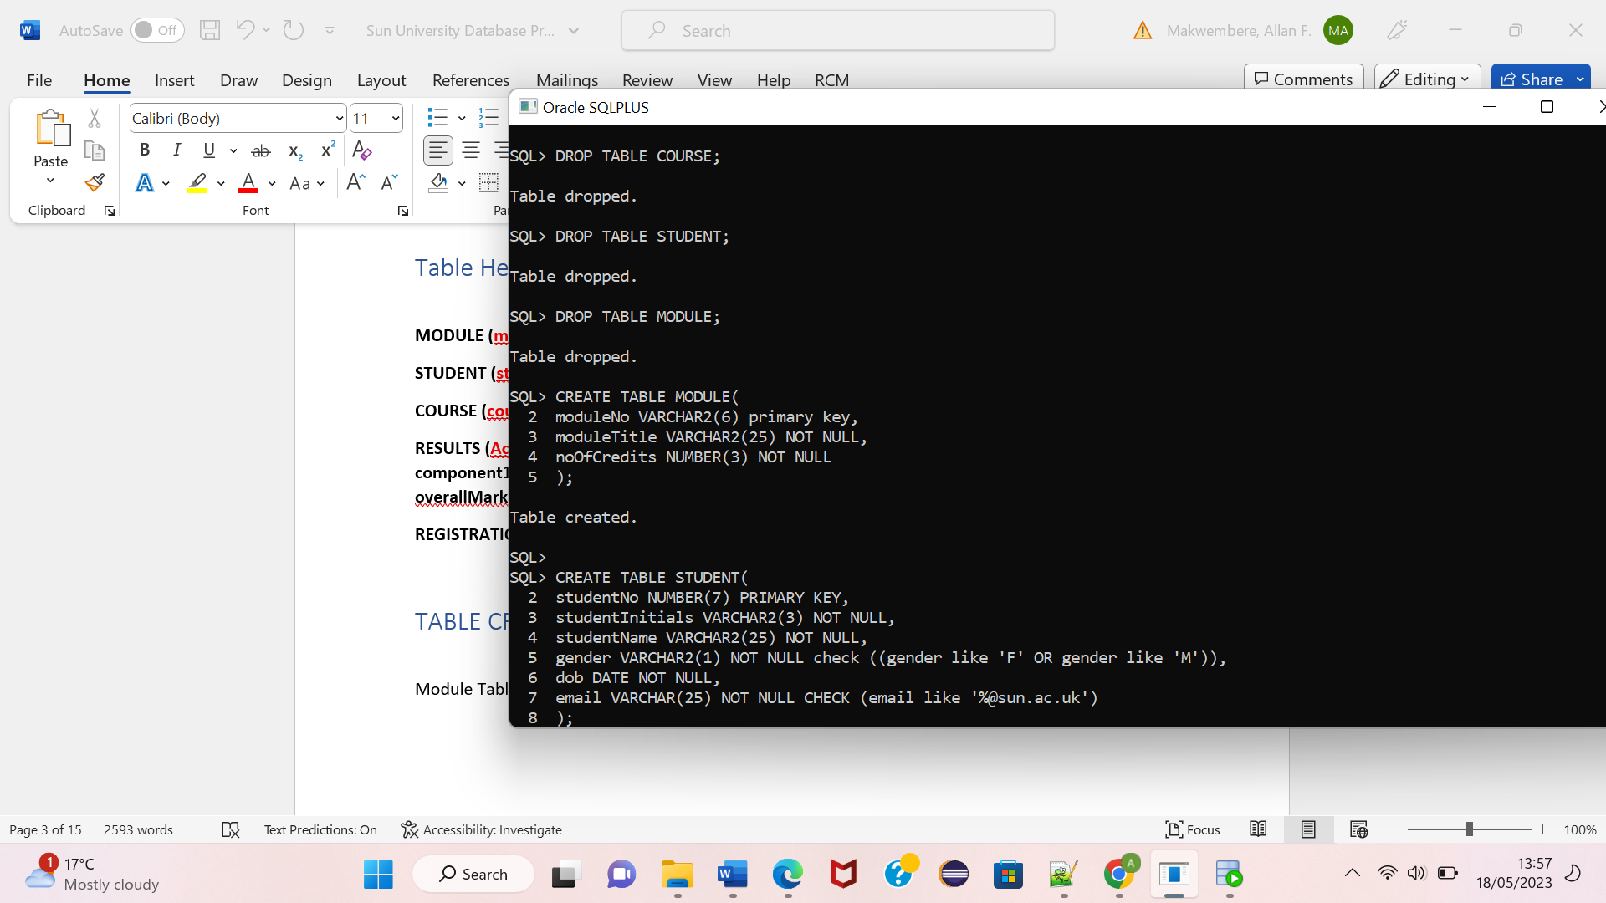

The above table makes use of the not null constraint for module title and noofcredits. This is done to prevent a user from leaving a column blank. There is also the primary key constraint on Module number.

**Student Table:**

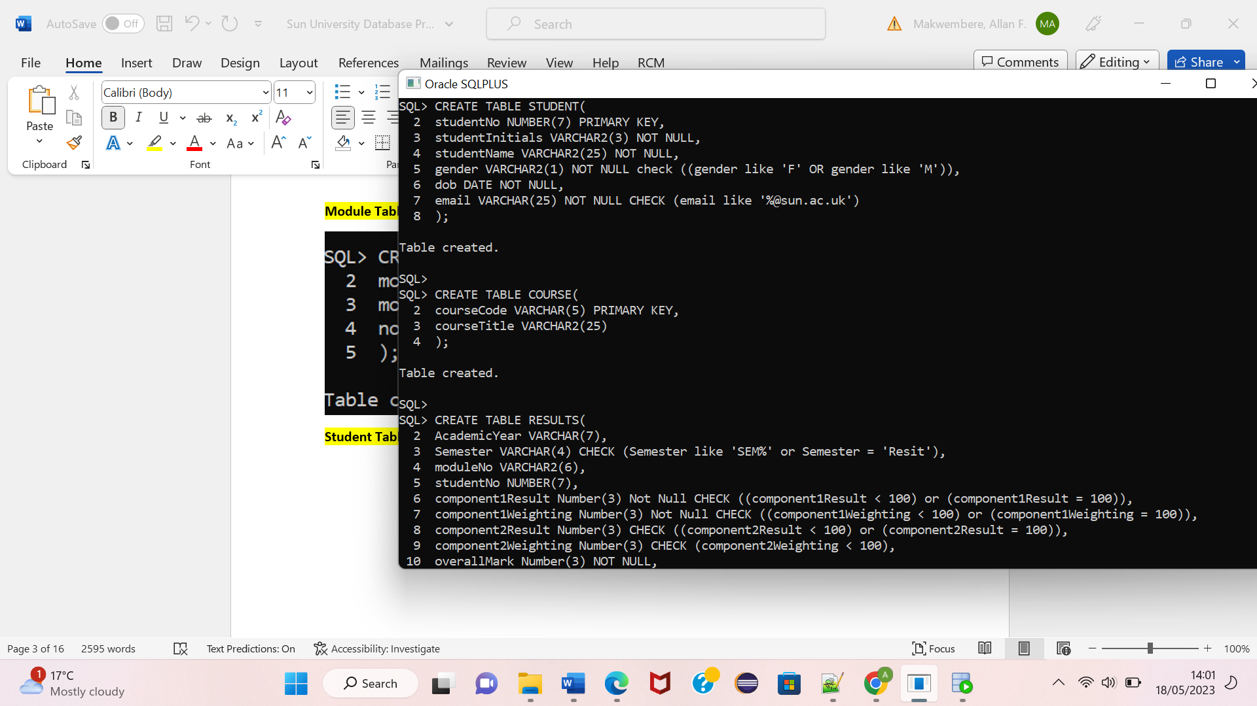

The above table uses the check constraint to monitor the gender if it fits the required type that can be entered into the column. This can either be ‘F’ or ‘M’ for female and male respectively. It also checks if the email fits the defined organization email.

**Course Table:**



**Results Table:**

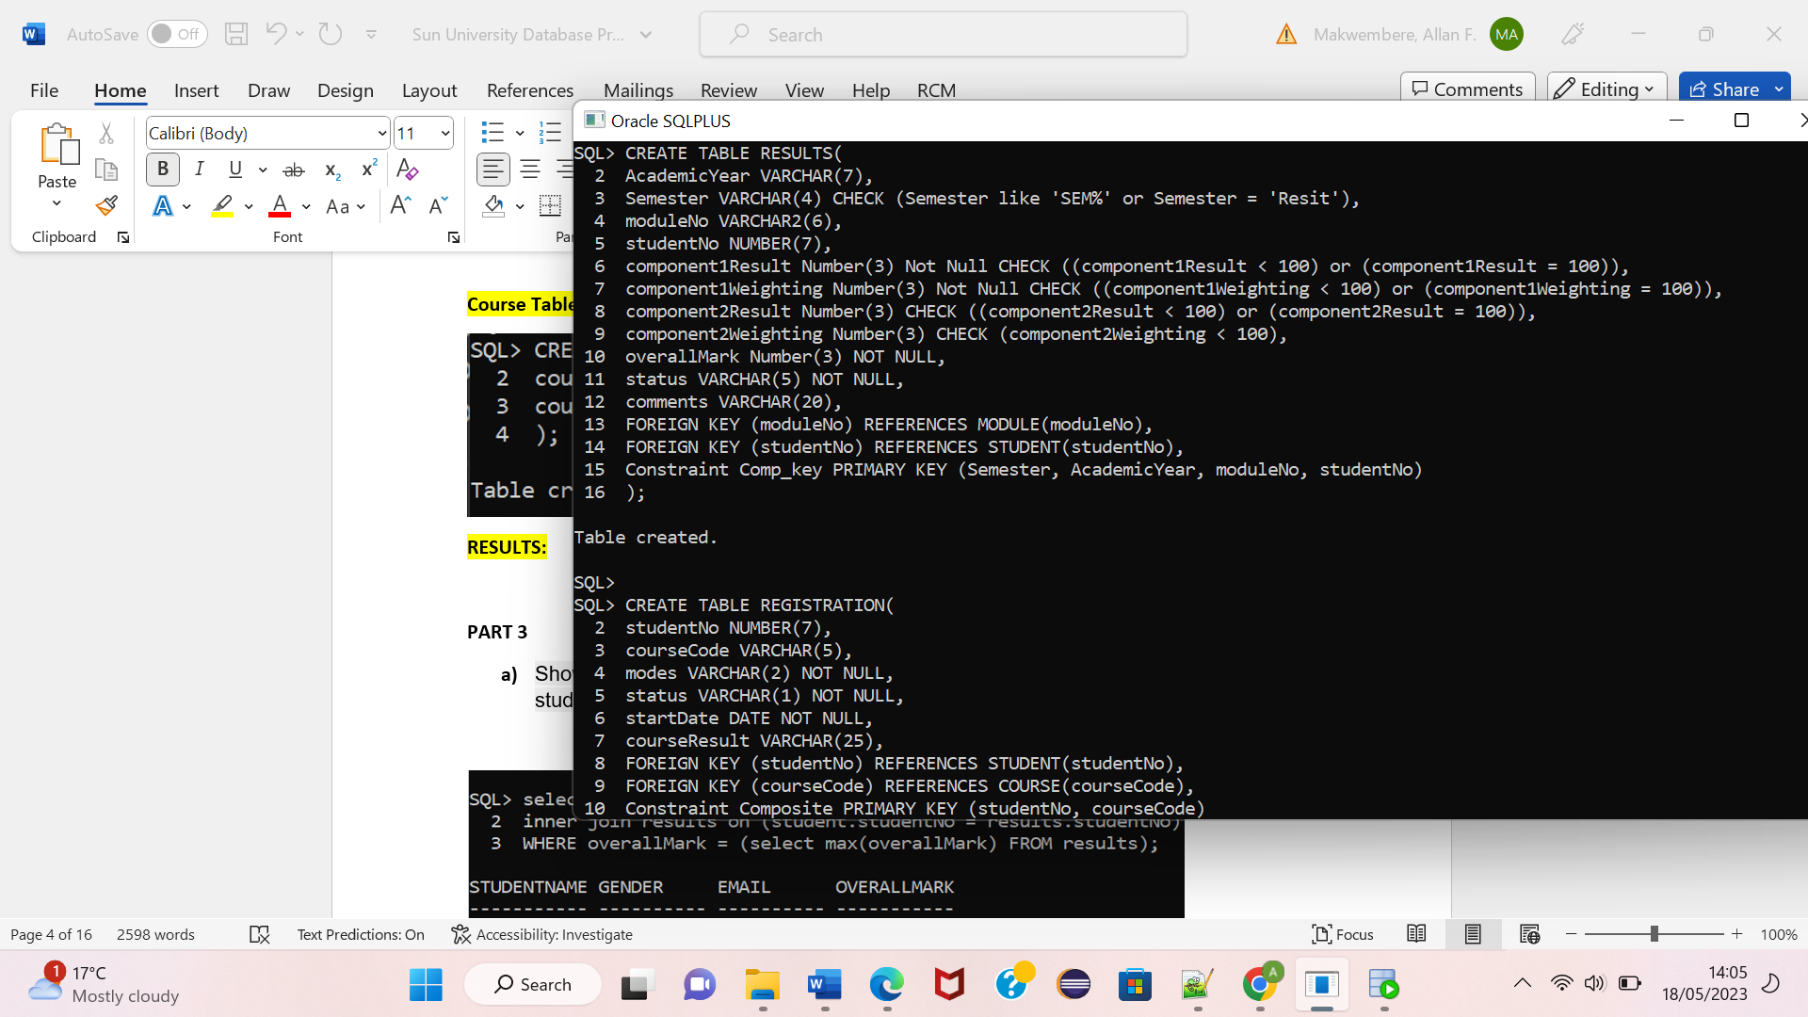

For the results table, foreign key constraints are also used to establish the one-to-many relationships with the module and student tables. A composite primary key is also used for the table to enforce data integrity and uniqueness.

**Registration Table:**

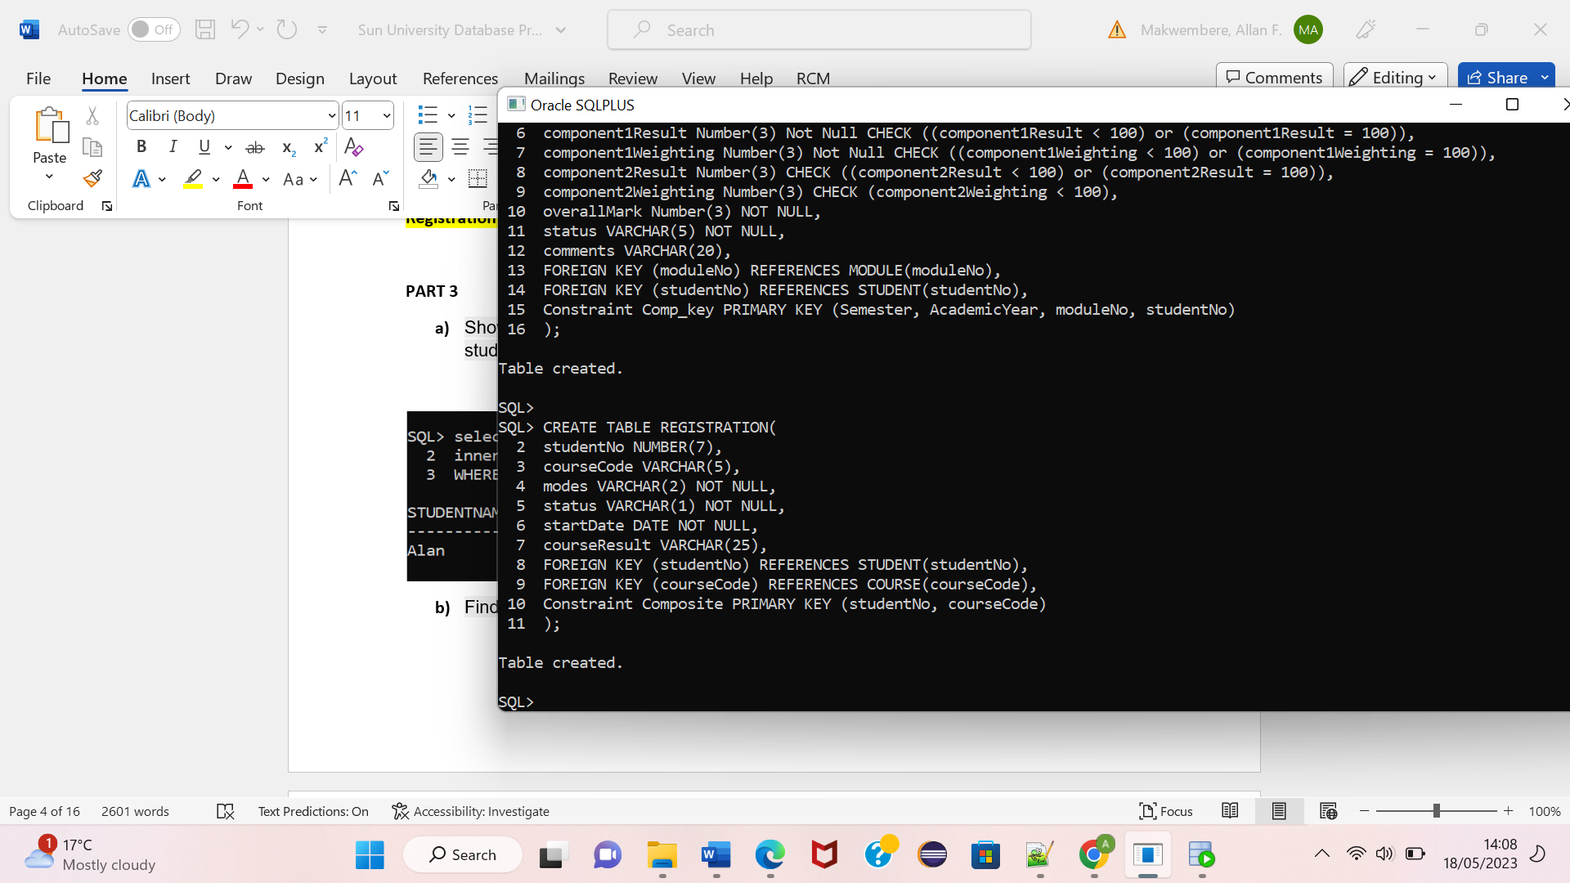

# Test Data

The contents of our tables are found below following their creation with the INSERT command:

**Module Table:**

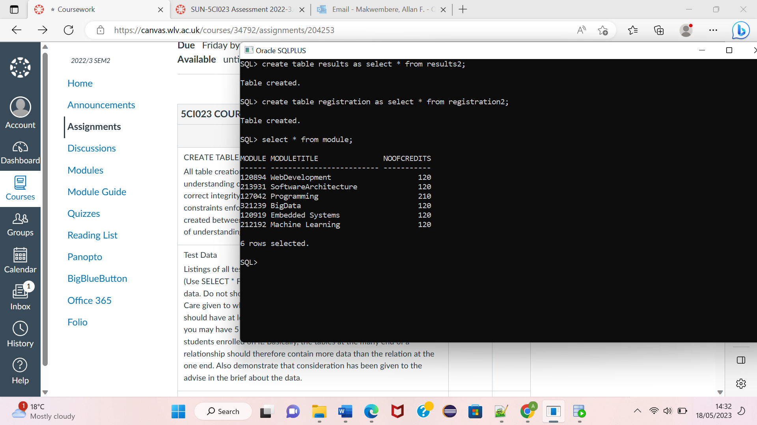

There are 6 modules in the module table. All of them have students enrolled in the module. Because of the relationship between the students table and the module table, it is expected that the modules will have more that one student enrolled.

**Student Table:**

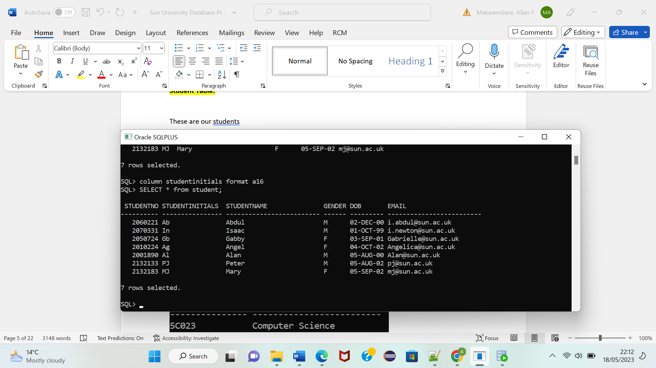

These are our students within the student table. Each of them is registered in a module with some modules having more than one student.

**Course Table:**

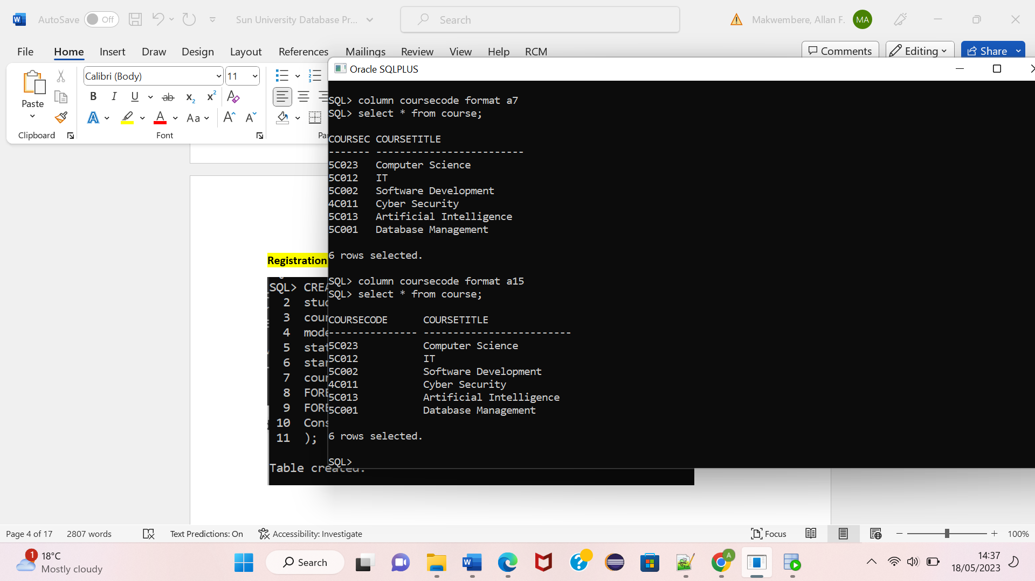

We have six courses, and all the courses have a student undertaking them. A student however, cannot be doing more than one course.

**Results Table:**

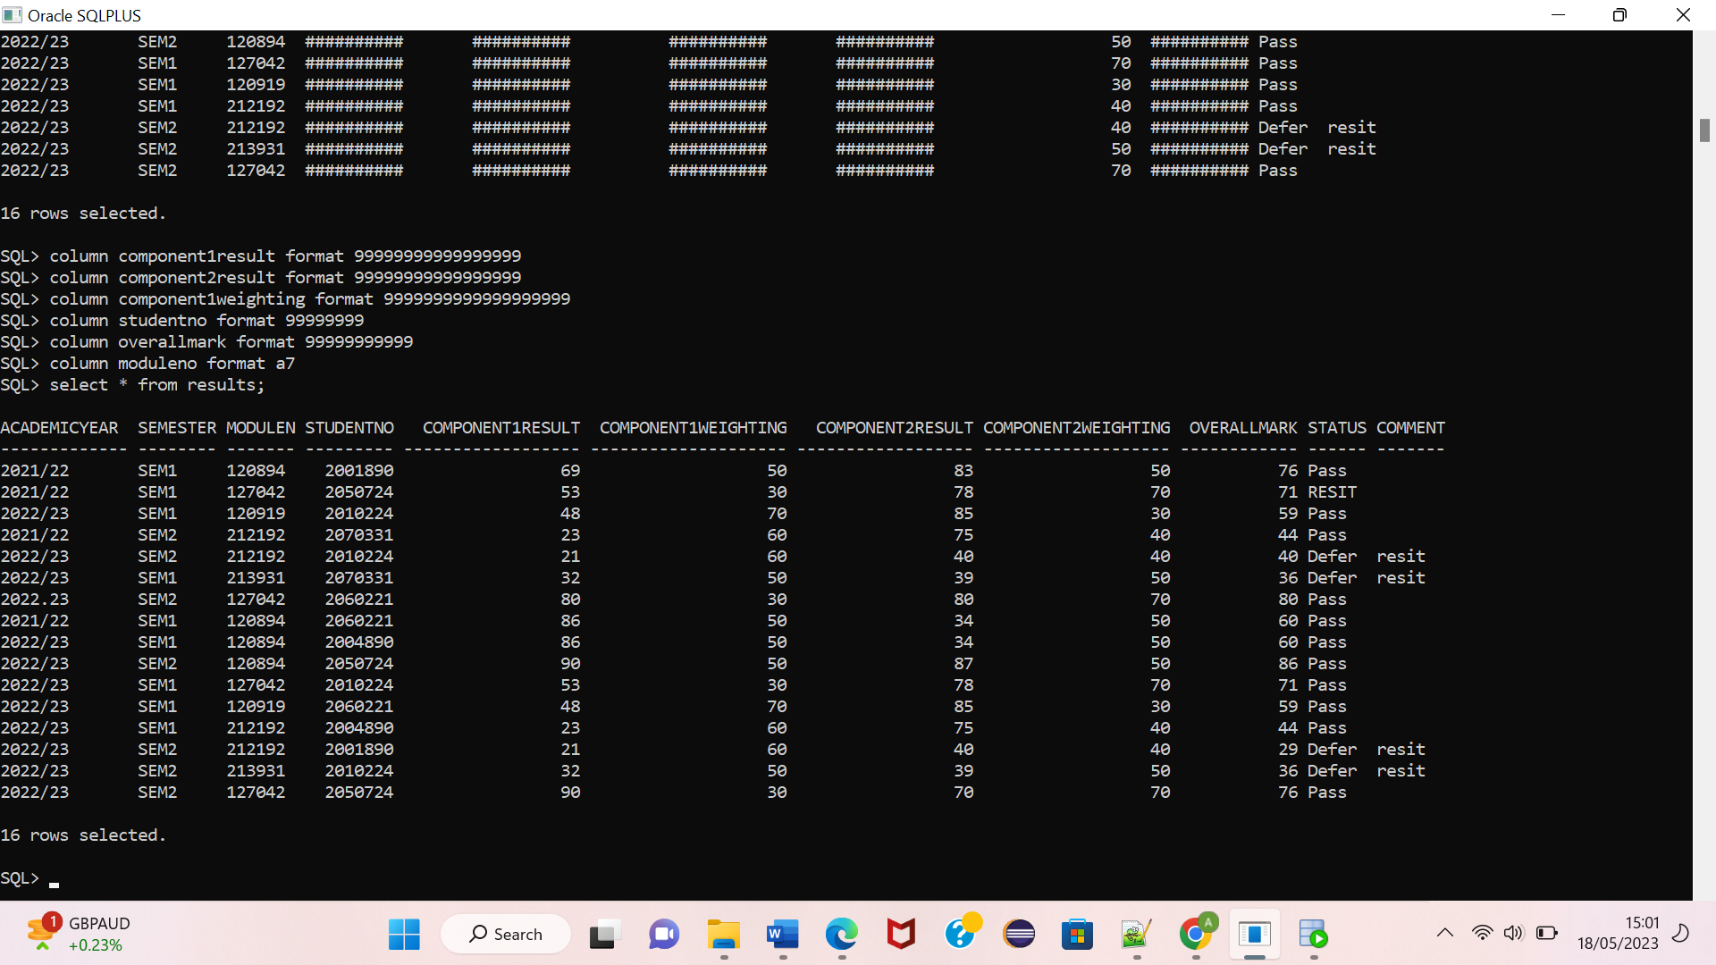

The results table stands at the many ends of its relationships with module and student. Therefore, it has more records than all the other tables as many modules can be undertaken by many students with the results being shown in the modules table.

**Registration Table:**

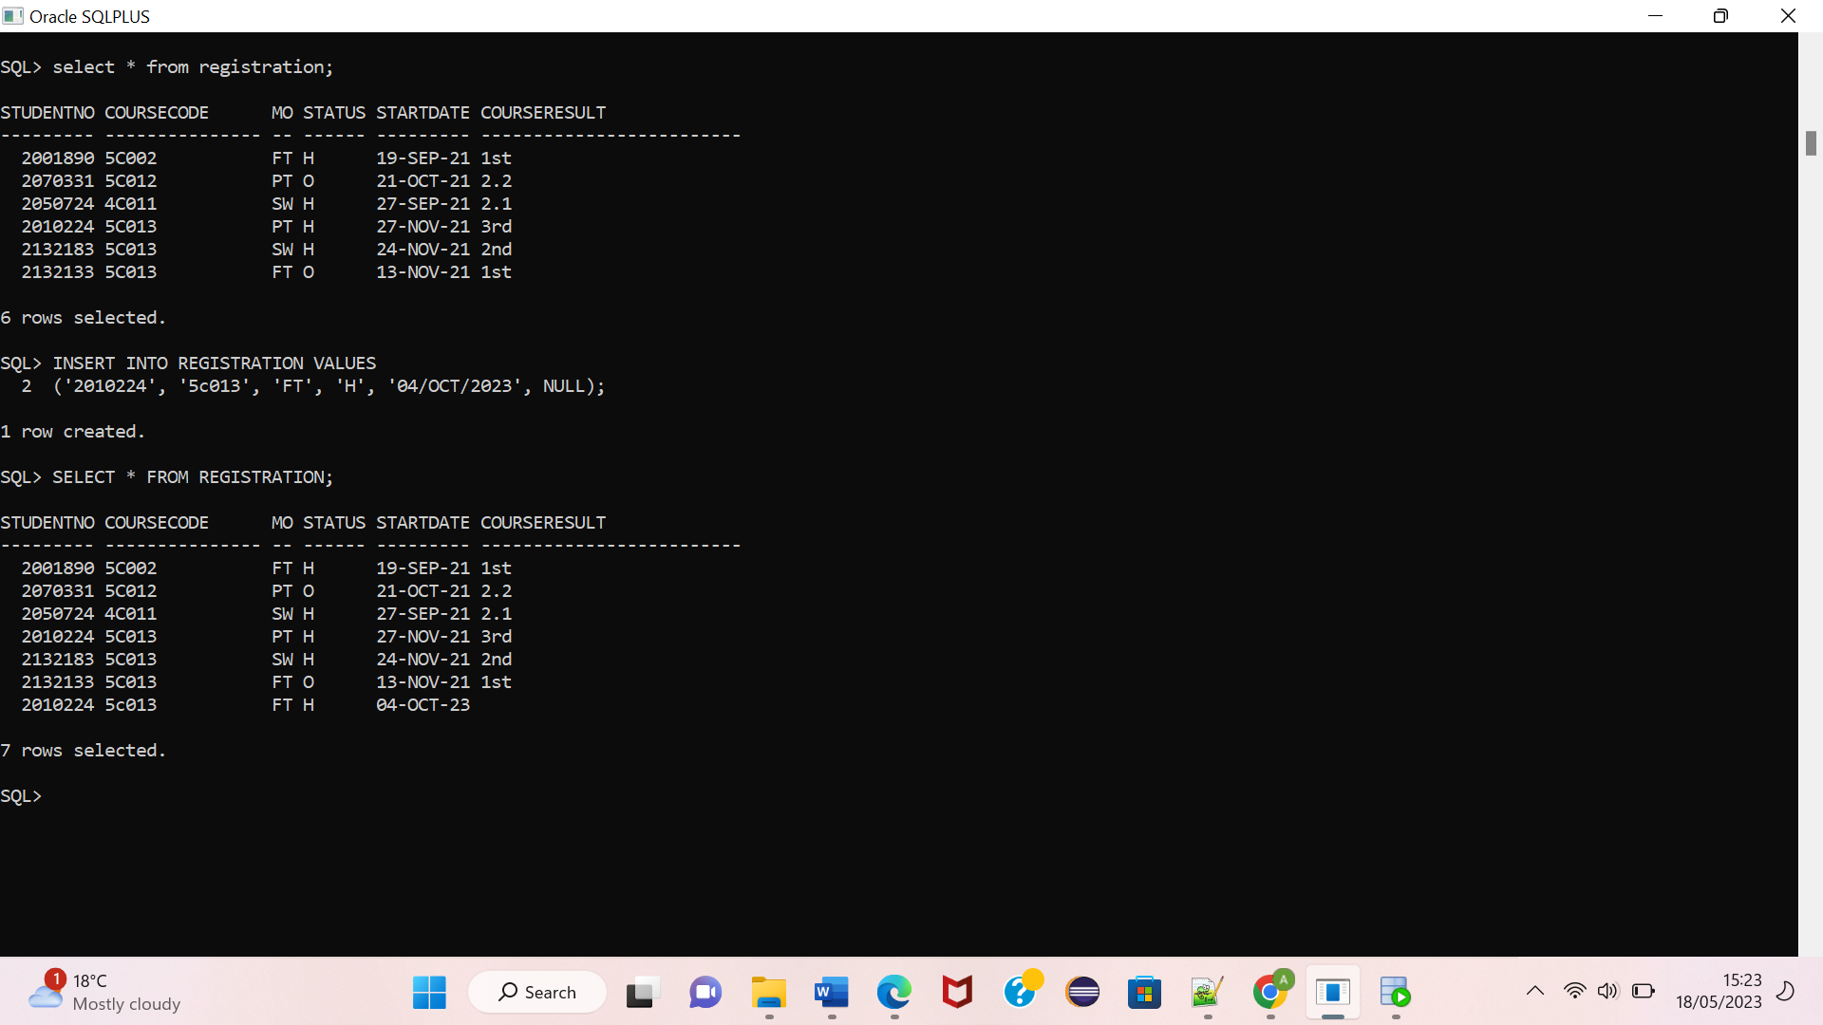

Although the registration table is also at the many end of its relationships with the tables course and student, all the students are only studying one course. While it is possible to have many records in the table without violating referential integrity, it may be illogical for one student to study more than one course.

# SQL Queries

1. Show details of the student that has the highest overall mark. Show the   
   student’s name, gender and email.

**SQL:**

SELECT STUDENTNAME, GENDER, EMAIL,

OVERALLMARK FROM STUDENT

INNER JOIN RESULTS ON

(STUDENT.STUDENTNO = RESULTS.STUDENTNO)

WHERE OVERALLMARK = (SELECT MAX(OVERALLMARK) FROM RESULTS)

/

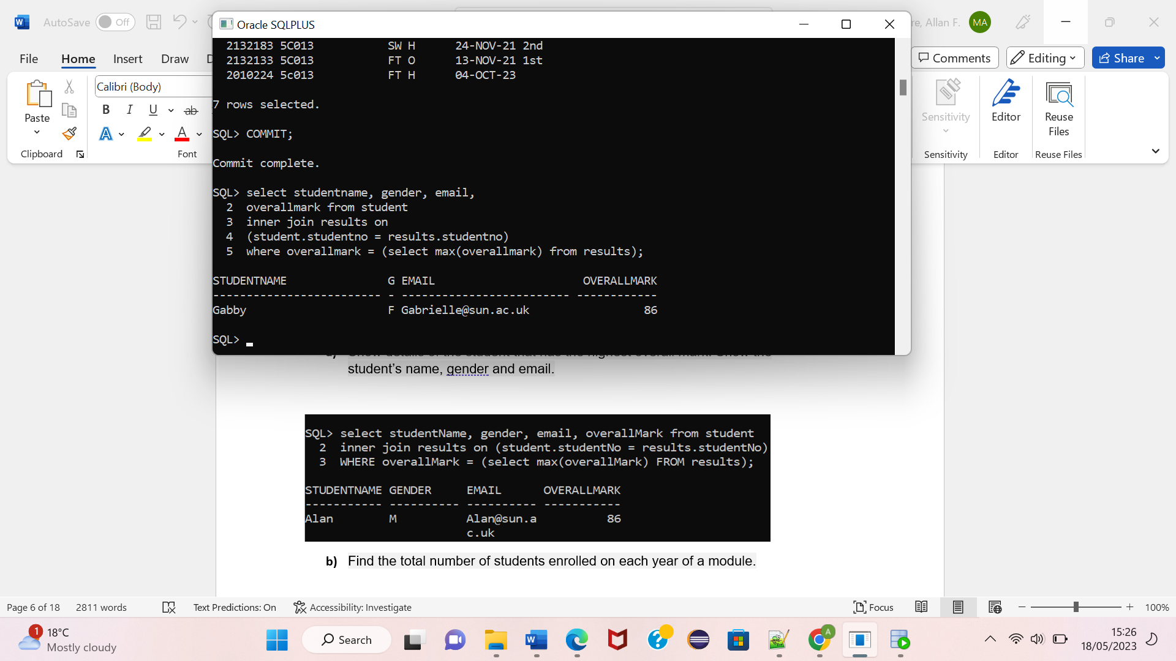

1. Find the total number of students enrolled on each year of a module.

**SQL:**

SELECT MODULE.MODULETITLE, RESULTS.ACADEMICYEAR AS YEAR,

COUNT(RESULTS.MODULENO) AS NUMBER_OF_STUDENTS_ENROLLED

FROM RESULTS

INNER JOIN MODULE ON RESULTS.MODULENO = MODULE.MODULENO

WHERE ((RESULTS.MODULENO = '120894') OR (RESULTS.MODULENO = '212192'))

GROUP BY MODULE.MODULETITLE, RESULTS.ACADEMICYEAR;

/

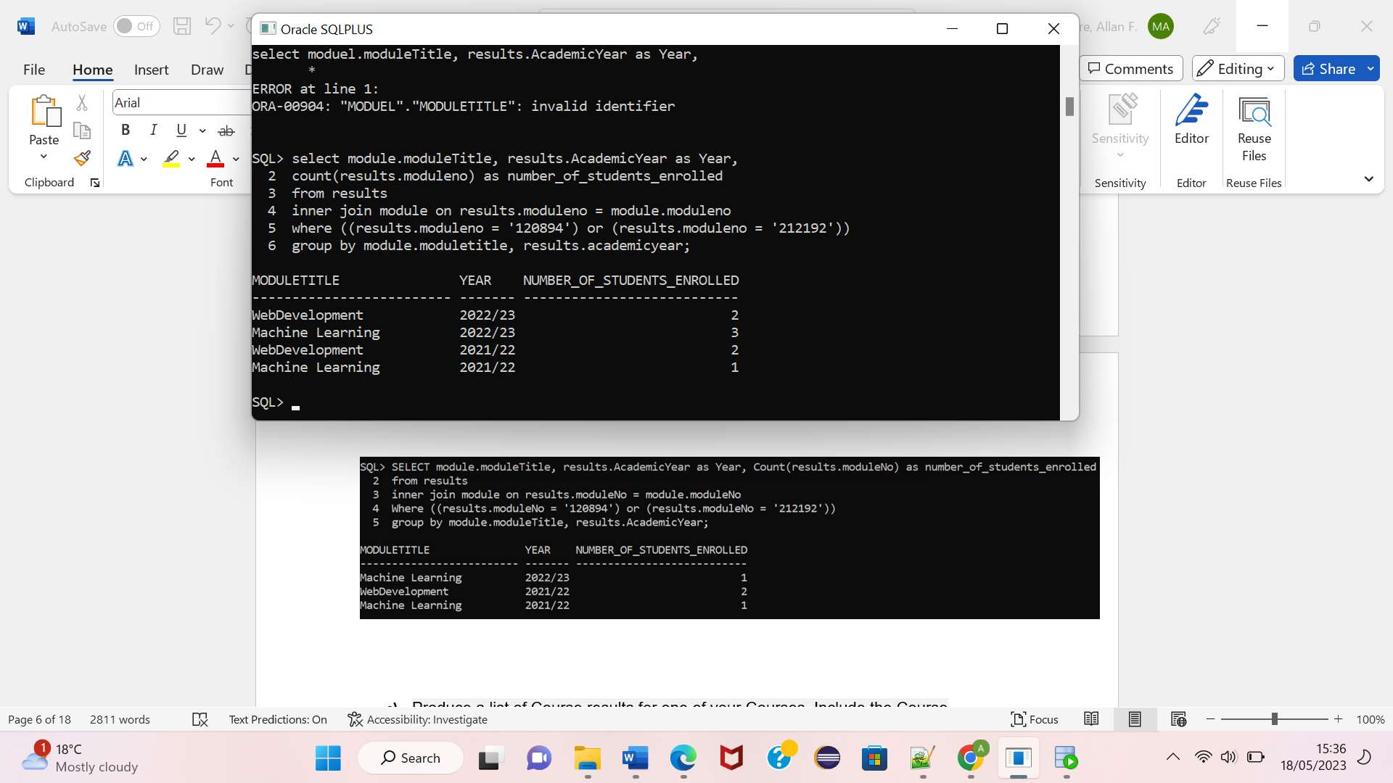

1. Produce a list of Course results for one of your Courses. Include the Course   
   Code, Course Title, the Student’s number, initials and name, their status   
   and the course result. Use a CASE construct to display the results as text   
   rather than numbers by transforming the values 1st, 2:1 and 3rd into the   
   words First, Upper Second and Third respectively. Any other value should   
   be displayed as is.

**SQL:**

SELECT COURSE.COURSETITLE, REGISTRATION.COURSECODE, REGISTRATION.STUDENTNO, REGISTRATION.STATUS,

(CASE REGISTRATION.COURSERESULT

WHEN '1st' THEN 'FIRST'

WHEN '2:1' THEN 'SECOND'

WHEN '3rd' THEN 'THIRD'

ELSE REGISTRATION.COURSERESULT

END) AS COURSERESULT,

(SELECT STUDENT.STUDENTNAME FROM STUDENT

WHERE REGISTRATION.STUDENTNO = STUDENT.STUDENTNO) AS STUDENTNAME,

(SELECT STUDENT.STUDENTINITIALS FROM STUDENT

WHERE REGISTRATION.STUDENTNO = STUDENT.STUDENTNO) AS STUDENTINITIALS

FROM REGISTRATION

INNER JOIN COURSE ON (COURSE.COURSECODE = REGISTRATION.COURSECODE)

WHERE COURSE.COURSECODE = '5C013';

/

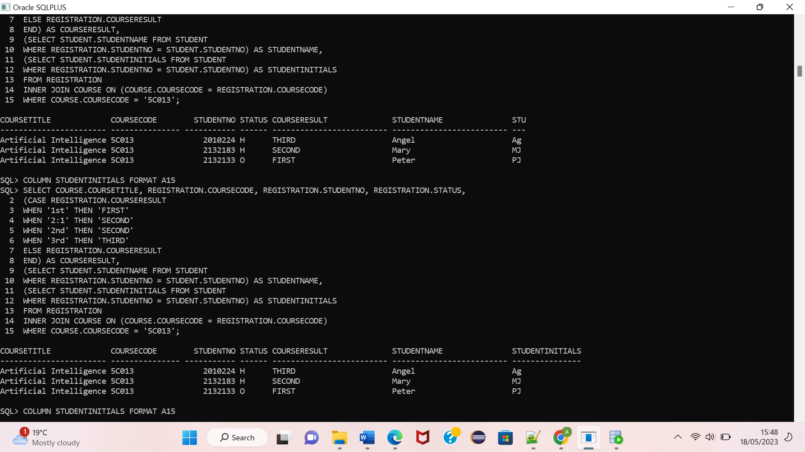

1. Find full details of the course that have less than two students. (You should   
   bear in mind that there may be some courses with no students registered.)

**SQL:**

SELECT COURSE.COURSETITLE, COURSE.COURSECODE, REGISTRATION.STUDENTNO, REGISTRATION.MODES,

REGISTRATION.STATUS, REGISTRATION.STARTDATE, REGISTRATION.COURSERESULT FROM COURSE

LEFT JOIN (

SELECT COURSECODE, STUDENTNO, MODES, STATUS, STARTDATE, COURSERESULT

FROM REGISTRATION

WHERE COURSECODE IN (

SELECT COURSECODE FROM REGISTRATION

GROUP BY COURSECODE

HAVING COUNT(*) = 1

)

UNION ALL

SELECT COURSECODE, NULL, NULL, NULL, NULL, NULL

FROM COURSE WHERE

COURSECODE NOT IN (

SELECT COURSECODE FROM REGISTRATION)

)REGISTRATION ON COURSE.COURSECODE = REGISTRATION.COURSECODE

WHERE REGISTRATION.COURSECODE IS NOT NULL;

/

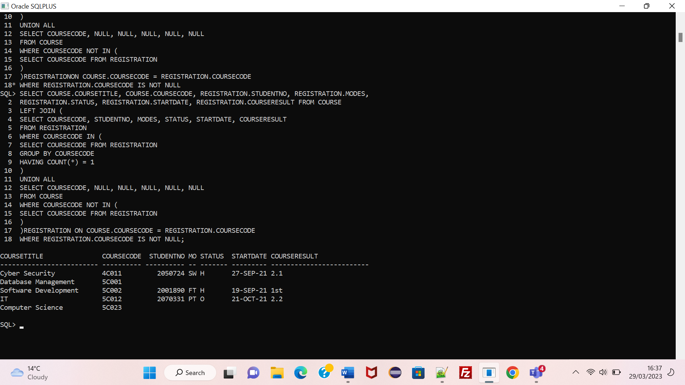

1. Find the names of all female Students who have an overall mark greater   
   than 60% in their SEM1 modules.

**SQL:**

SELECT STUDENTNAME, GENDER, OVERALLMARK, SEMESTER FROM STUDENT

INNER JOIN RESULTS ON (STUDENT.STUDENTNO = RESULTS.STUDENTNO)

WHERE (GENDER = 'F') AND (OVERALLMARK > 60) AND (SEMESTER = 'SEM1')

/

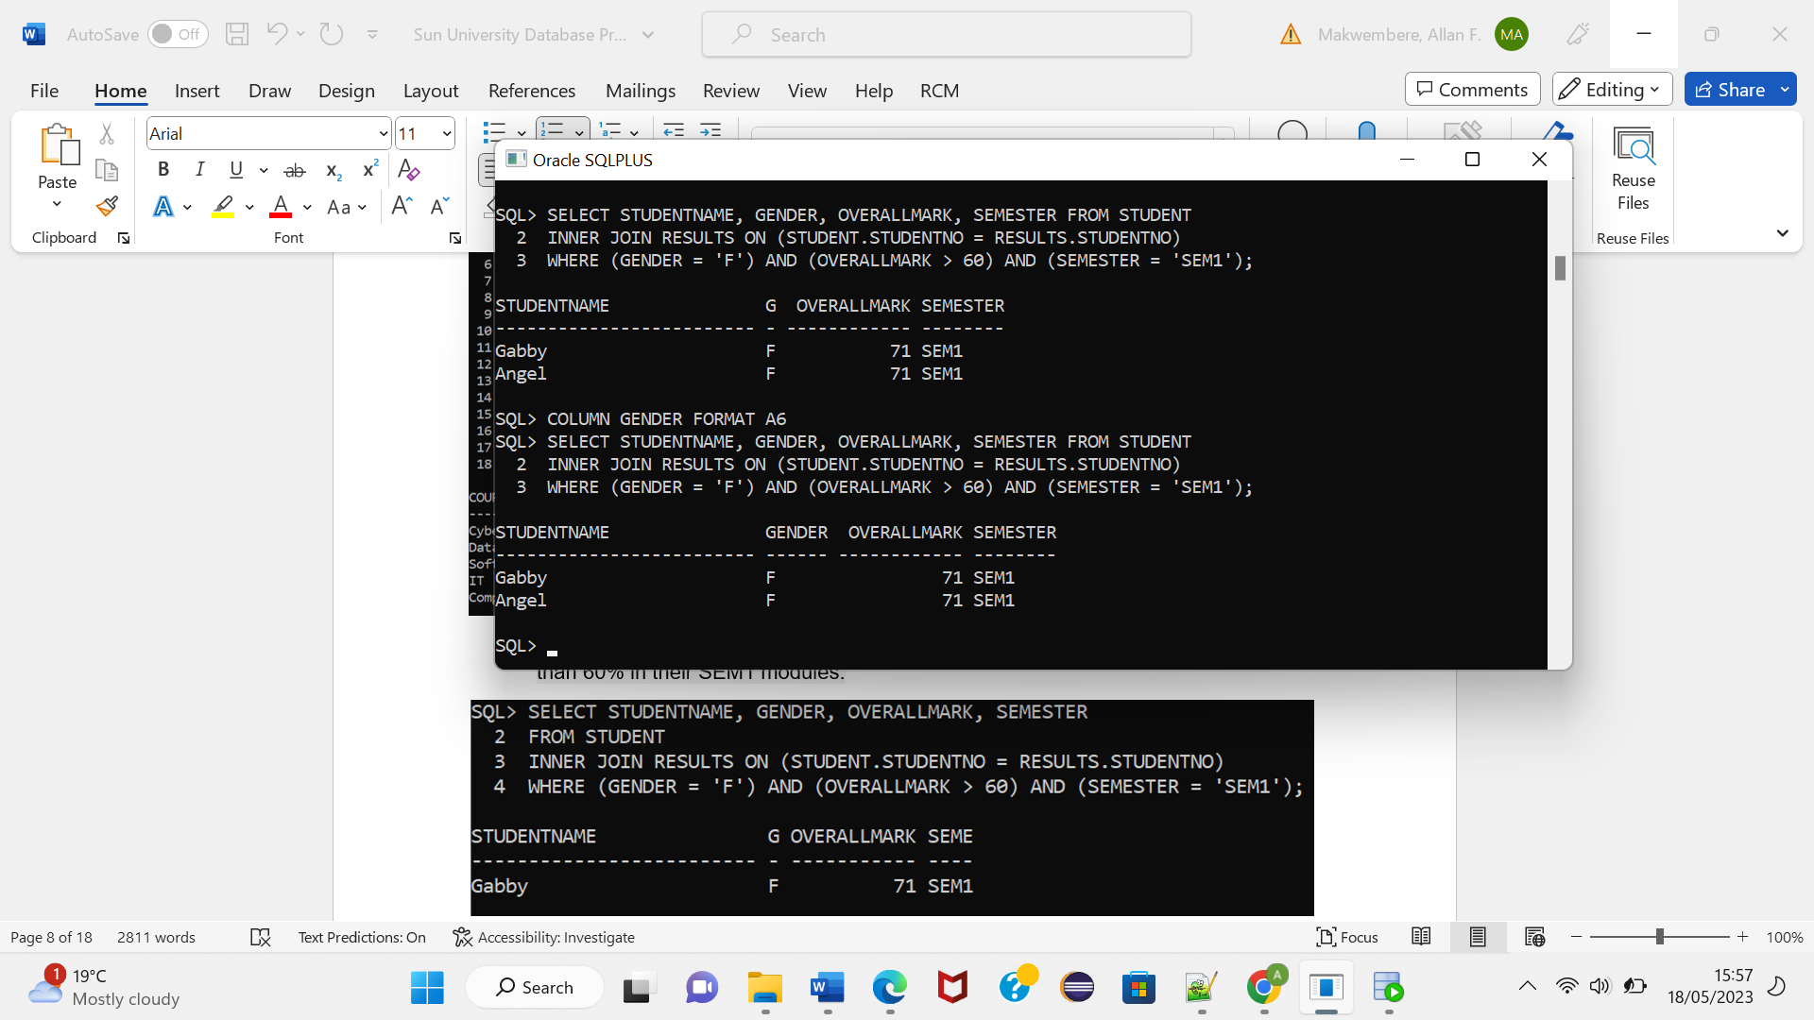

# **CUSTOM QUERIES**

Below are queries that are separate from those given in the prompt.

**1.**

SQL:

SELECT STUDENT.STUDENTNO, RESULTS.STATUS, RESULTS.OVERALLMARK, RESULTS.MODULENO,

(CASE

WHEN

RESULTS.OVERALLMARK >= 60 THEN 'MERIT'

WHEN

RESULTS.OVERALLMARK >= 50 THEN 'PASS'

WHEN

RESULTS.OVERALLMARK >= 80 THEN 'DISTINCTION'

WHEN

RESULTS.OVERALLMARK >= 49 THEN 'FAIL'

END) AS GRADE

FROM RESULTS INNER JOIN STUDENT ON STUDENT.STUDENTNO = RESULTS.STUDENTNO;

/

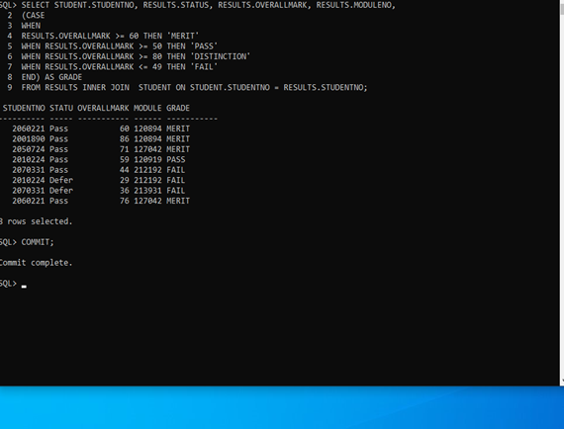

The SQL query provided retrieves the **studentno**, **status**, **overallmark**, **moduleno**, and a calculated **grade** of the **overallmark** from the **results** table. It performs an INNER JOIN task with the **student** table which includes the matching student number. It then uses a case statement to check the overall marks according to the case statement defined grades.

**2.**

SQL:

SELECT STUDENT.STUDENTNAME, REGISTRATION.STUDENTNO

FROM STUDENT

JOIN REGISTRATION ON STUDENT.STUDENTNO = REGISTRATION.STUDENTNO

WHERE REGISTRATION.COURSECODE = '5C002' AND STARTDATE > TO_DATE('12/SEP/2021', 'DD/MON/YYYY');

/

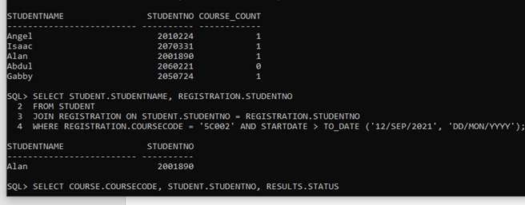

This query includes the **STUDENTNAME** and **STUDENTNO** of students who are being registered for the course with course code '5C002' and have a start date after September the 12th, 2021.

**3.**

SQL:

SELECT STUDENT.STUDENTNAME, STUDENT.STUDENTNO,

COUNT(REGISTRATION.COURSECODE) AS COURSE_COUNT

FROM STUDENT

LEFT JOIN REGISTRATION ON STUDENT.STUDENTNO = REGISTRATION.STUDENTNO

GROUP BY STUDENT.STUDENTNAME, STUDENT.STUDENTNO

ORDER BY COURSE_COUNT DESC

FETCH FIRST 2 ROWS ONLY

/

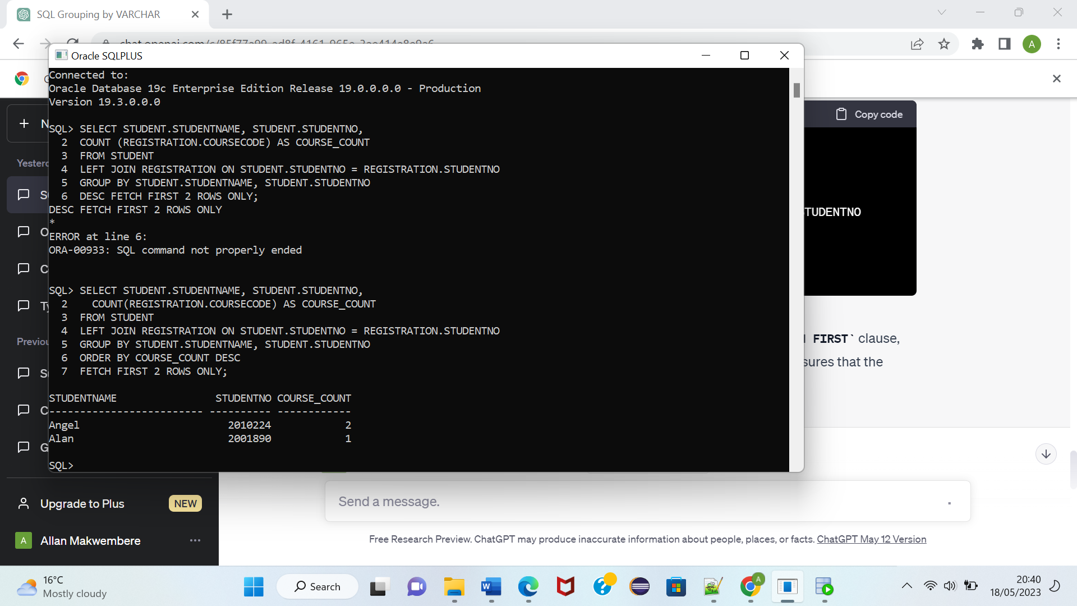

This SQL query gets the **studentname,studentno**, and the count of **coursecode** registrations for each student from the **student** table. Then uses a LEFT JOIN with the **registration** table to include all students, even if they do not have registrations. It then groups the results by the studentname and student number. The order by function then sorts the result set into descending order based on Course_count. However only the first 2 rows are needed in the query.

**4.**

SQL:

SELECT MAX(RESULTS.OVERALLMARK) AS HIGHEST_GRADE,

ROUND(AVG(RESULTS.OVERALLMARK)) AS AVERAGE_MARKS_FOR_STUDENTS,

RESULTS.MODULENO, MODULE.MODULETITLE

FROM

RESULTS

INNER JOIN MODULE ON RESULTS.MODULENO = MODULE.MODULENO

GROUP BY

results.MODULENO, module.MODULETITLE;

/

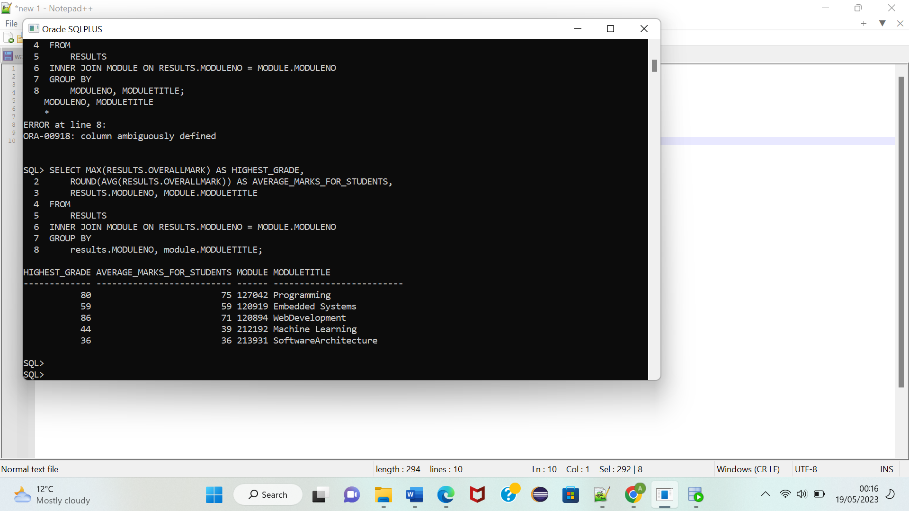

In this query, I used the max function to calculate the highest mark of a module and the avg function to find the highest mark of a module. I used an inner join to find the module title as well.

# View Definitions and Testing

1. The following is a view that shows all the students details along with their module  
   results (moduleNo, academic year, semester, overall mark and status  
   only). I did not include students who have not taken any modules yet.

**SQL:**

CREATE OR REPLACE VIEW STUDENT_DETAILS AS

SELECT STUDENT.STUDENTNO, STUDENTNAME, STUDENTINITIALS, GENDER, DOB, EMAIL,

RESULTS.MODULENO, ACADEMICYEAR, SEMESTER, OVERALLMARK, STATUS FROM RESULTS

INNER JOIN STUDENT ON (STUDENT.STUDENTNO = RESULTS.STUDENTNO)

WHERE STUDENT.STUDENTNO IN (SELECT STUDENTNO FROM RESULTS)

/

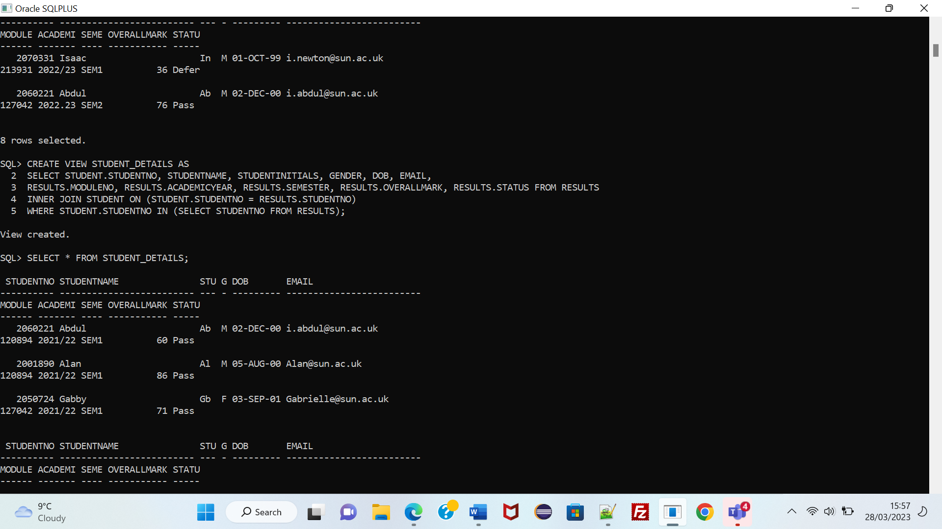

CONTENTS

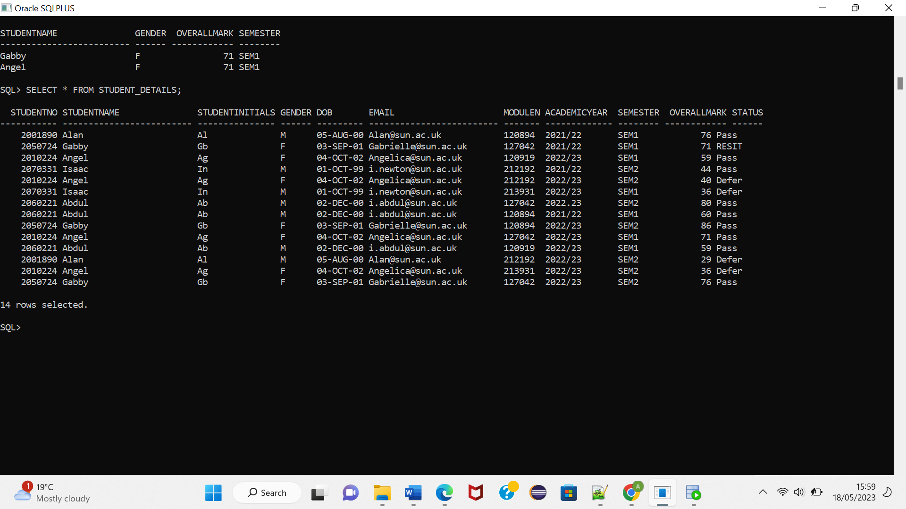

# Testing

1. **Update on each individual column within the view**

In order to test the views ability to support DML activity, I first tested the UPDATE statement of all the columns. There were quite a few unique responses.

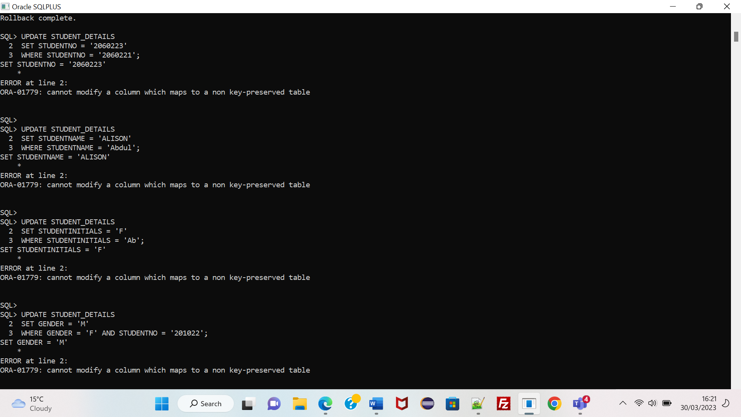

Most of the updates I tried to make generated an error message because they were in a non-key-preserved tables. In key-preserved tables there is a one-to-one mapping or relationship to the rows to which they are joined to. This is by means of a primary key or unique key.

Therefore, all the error messages have one thing in common, they occur after an attempt to update the columns belonging to the student table which is not guaranteed to preserve the key, StudentNo, in the view. This is because the student table is not being selected with a unique identifier in the query, and it is being joined to the Results table using a foreign key, (student.studentno = results.studentno).

It is also difficult and impossible to make updates on views that contain a subquery. The above view uses a subquery in its declared statement, making it difficult to be updateable.

However, not all update statements gave out the same error.

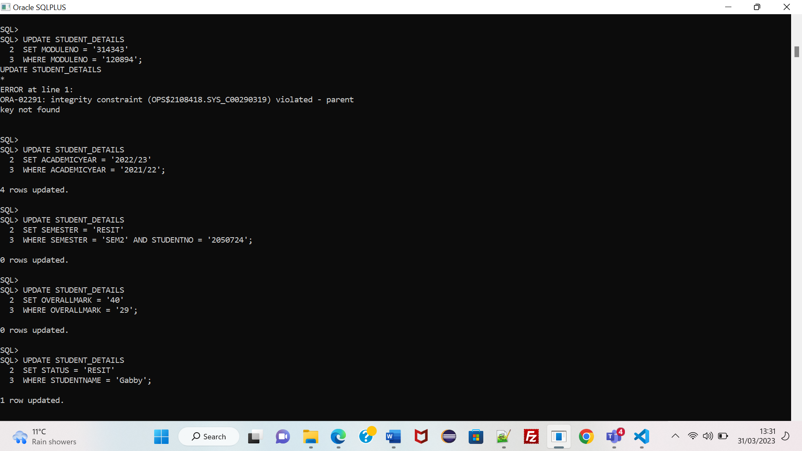

The update on moduleNo is impossible because it is attempting to update the column visible on the view but not from its parent table. The moduleNo in the view is simply a foreign key in a child table and any update would violate integrity.

The last four updates were successful because they are updating columns whose underlying table is the Results table. The table satisfies the key-preservation requirement as it is being joined to the student table using a studentno foreign key, which maps to a unique identifier in the student table.

1. Insert of new rows into the view

Insertion into the view is impossible due to the non-key-preserved table. When the insert query is initiated, the view does not have a unique identifier to distinguish the row from the others. This is chiefly because of the Student table which does not have key associated with its rows as it was joined from a foreign key.

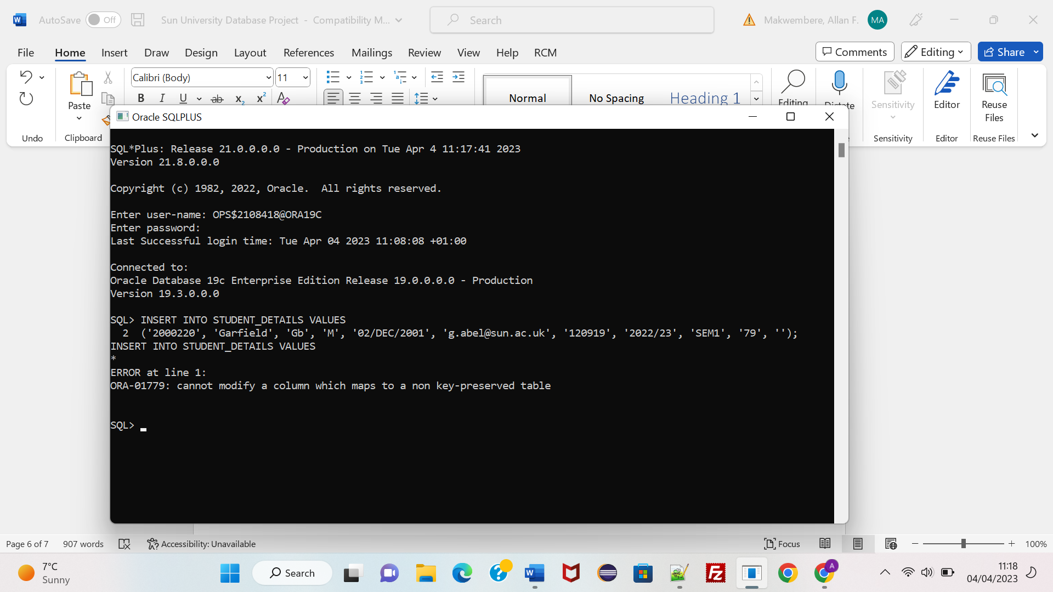

1. Deletes of rows from view

The deletion of rows is possible if it does not violate constraints. Here the deletion is possible however, the query ends up deleting more than one row because StudentNo is not unique. As a result, more conditions are needed in the where clause. The deletion clause also successfully deletes from the base underlying table.

‘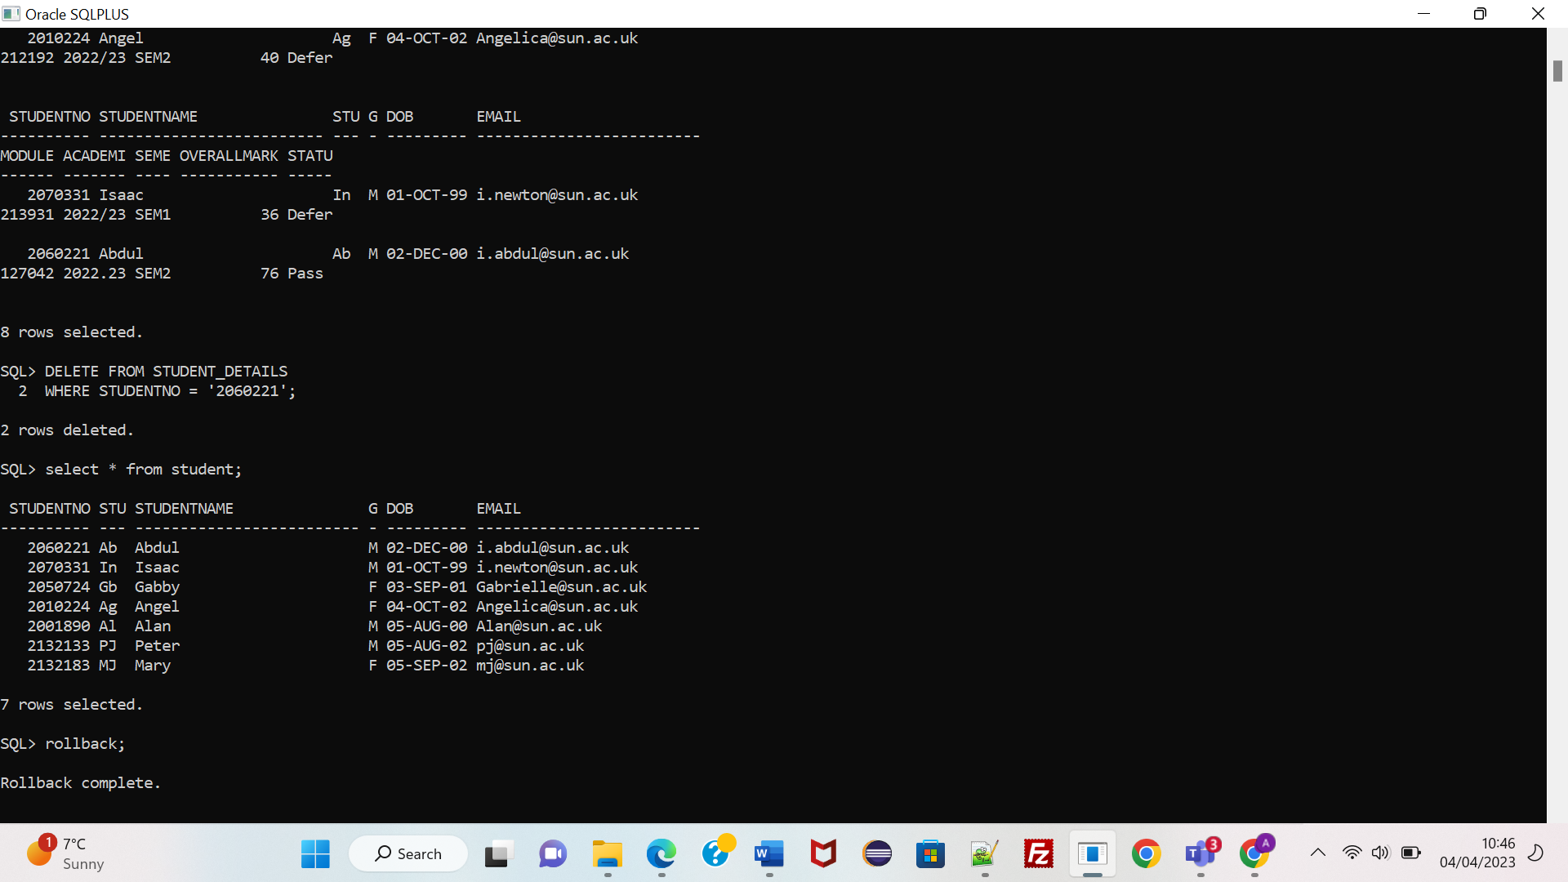

# Audit trigger and methods

In order to maintain the intergrity of the data within the tables, triggers need to be put in place to curb some of the limitations of constraints. I identified one particular table that could be altered by third parties which could lead to data loss or unlawful changes. The Results table.

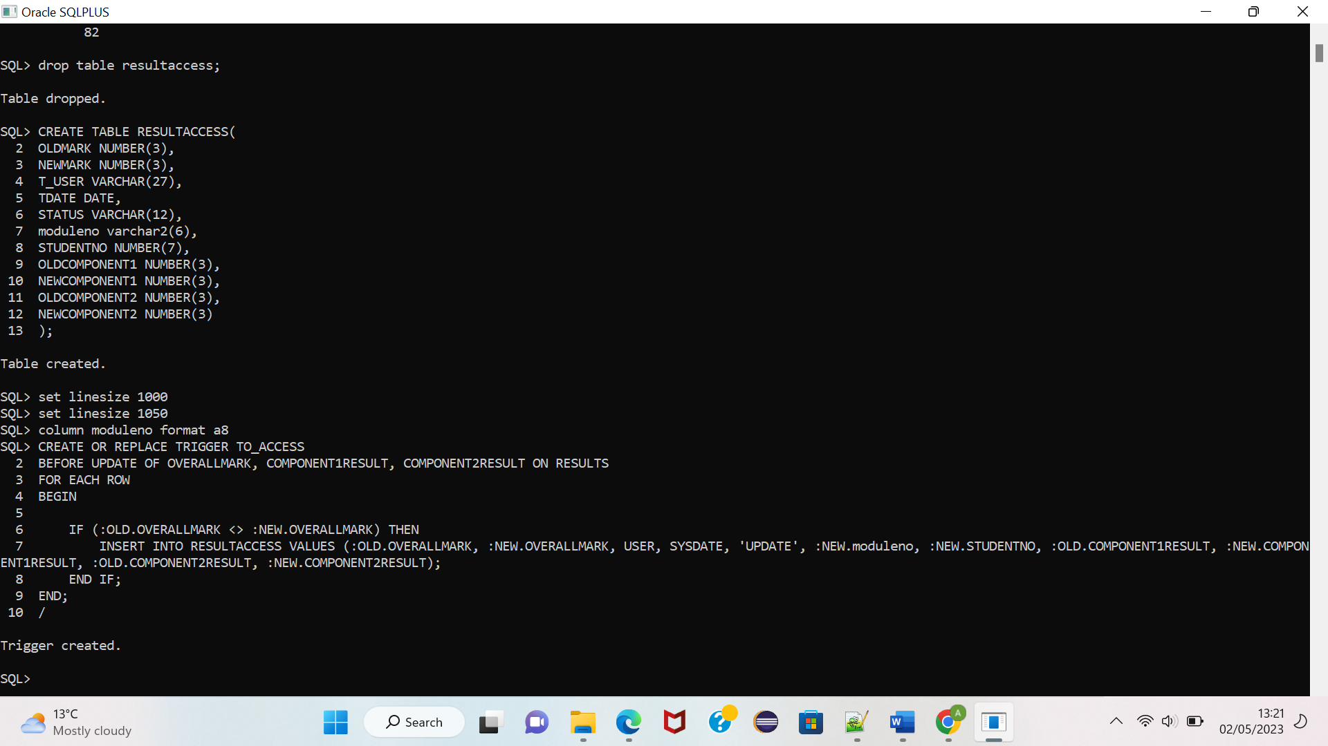We mainly chose the table because it contains examination and coursework marks which are necessary for the students to justify their education status. If these marks are altered or lost in any way, a student may not be able to graduate or advance to the next level.

So, first we created an audit table to store the results of executed triggers and audit trails. We named it Resultaccess. Within the table, we store the previous values and the changes made as shown by oldmark and newmark (pertaining to overallmark). We also store the changes made to the components as well along with the previous values (pertaining to component results). This ensures that we keep a copy of the data in the audit table should it be altered or changed.

The audit table also includes the composite primary key columns of the results table, moduleno and studentno. This makes it easier to locate the source of an audit trail within the results table.

The audit table also contains the user or account responsible for the changes that have been made. This will be stored in T_USER. TDATE will store the date that the transaction occurred. Status on the other hand will store the type of change that has been undertaken by the user or account. This can be an update or deletion. This will make it easier to identify the changes that were made.

# Update and Insert

To monitor the updates done within the results table, I created the trigger To_access. This trigger stores any changes that have been made into the audit table. If, however, the update has resulted in no changes occurring, it does not store anything. 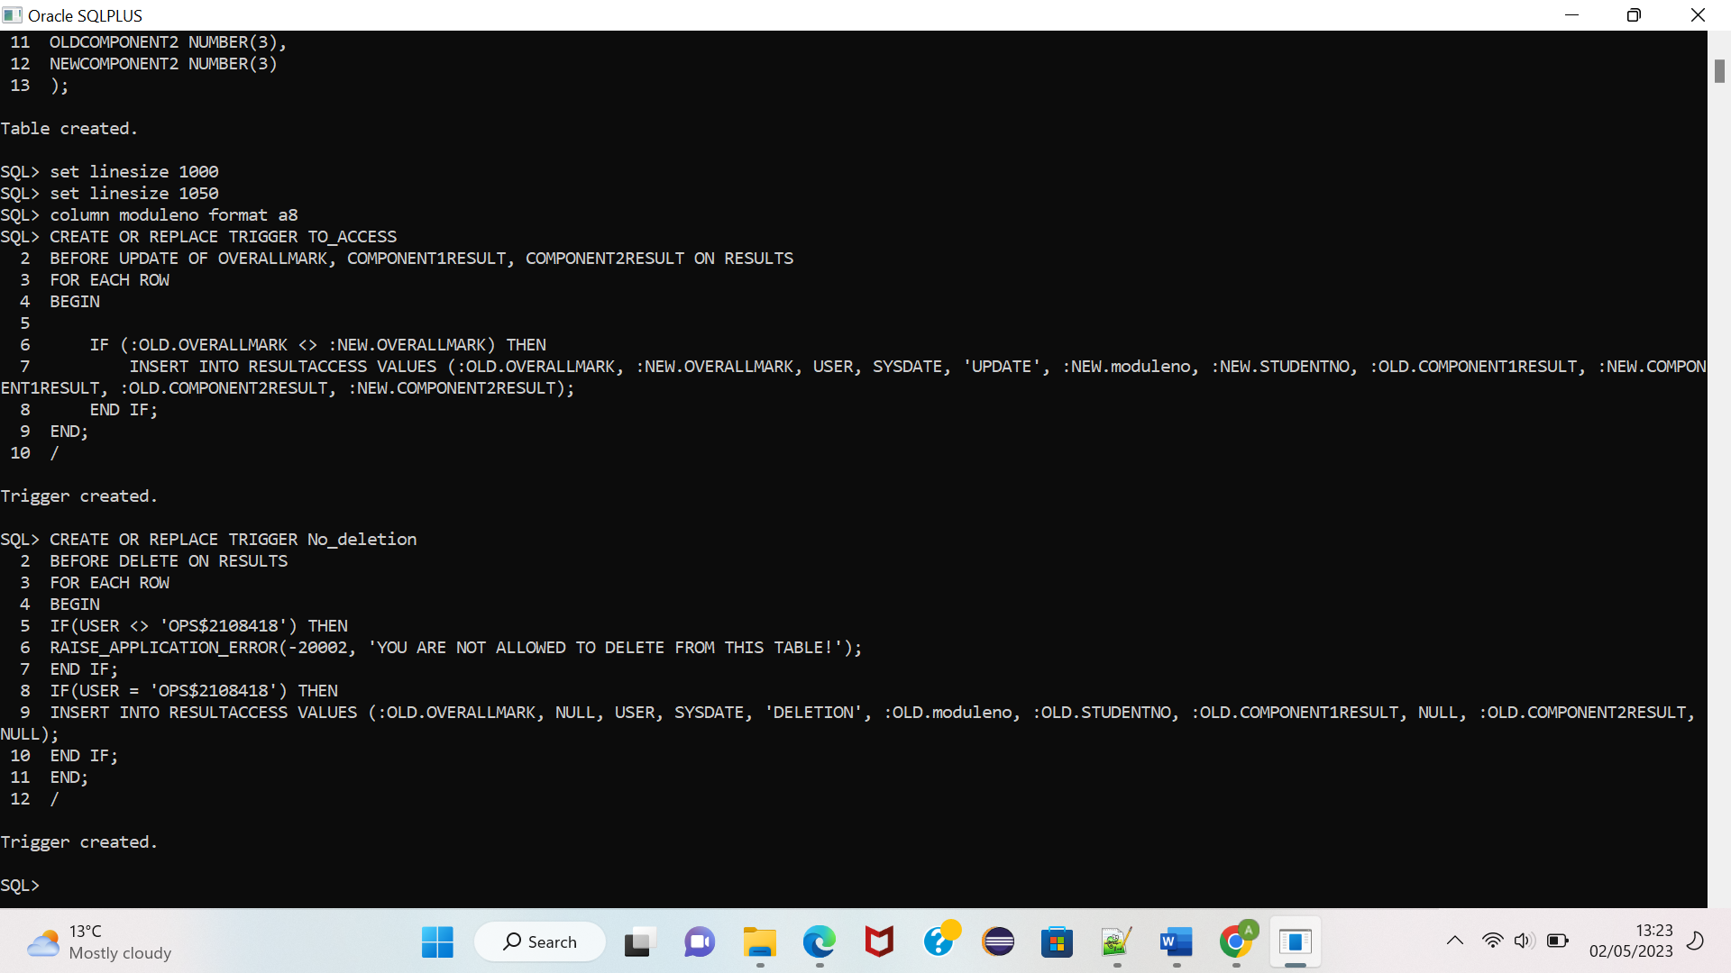

To test the trigger, a user that does not have administrative privileges within the table had to do the update. So, we used another oracle account using DCL to grant privileges to the results table. The update was therefore as follows: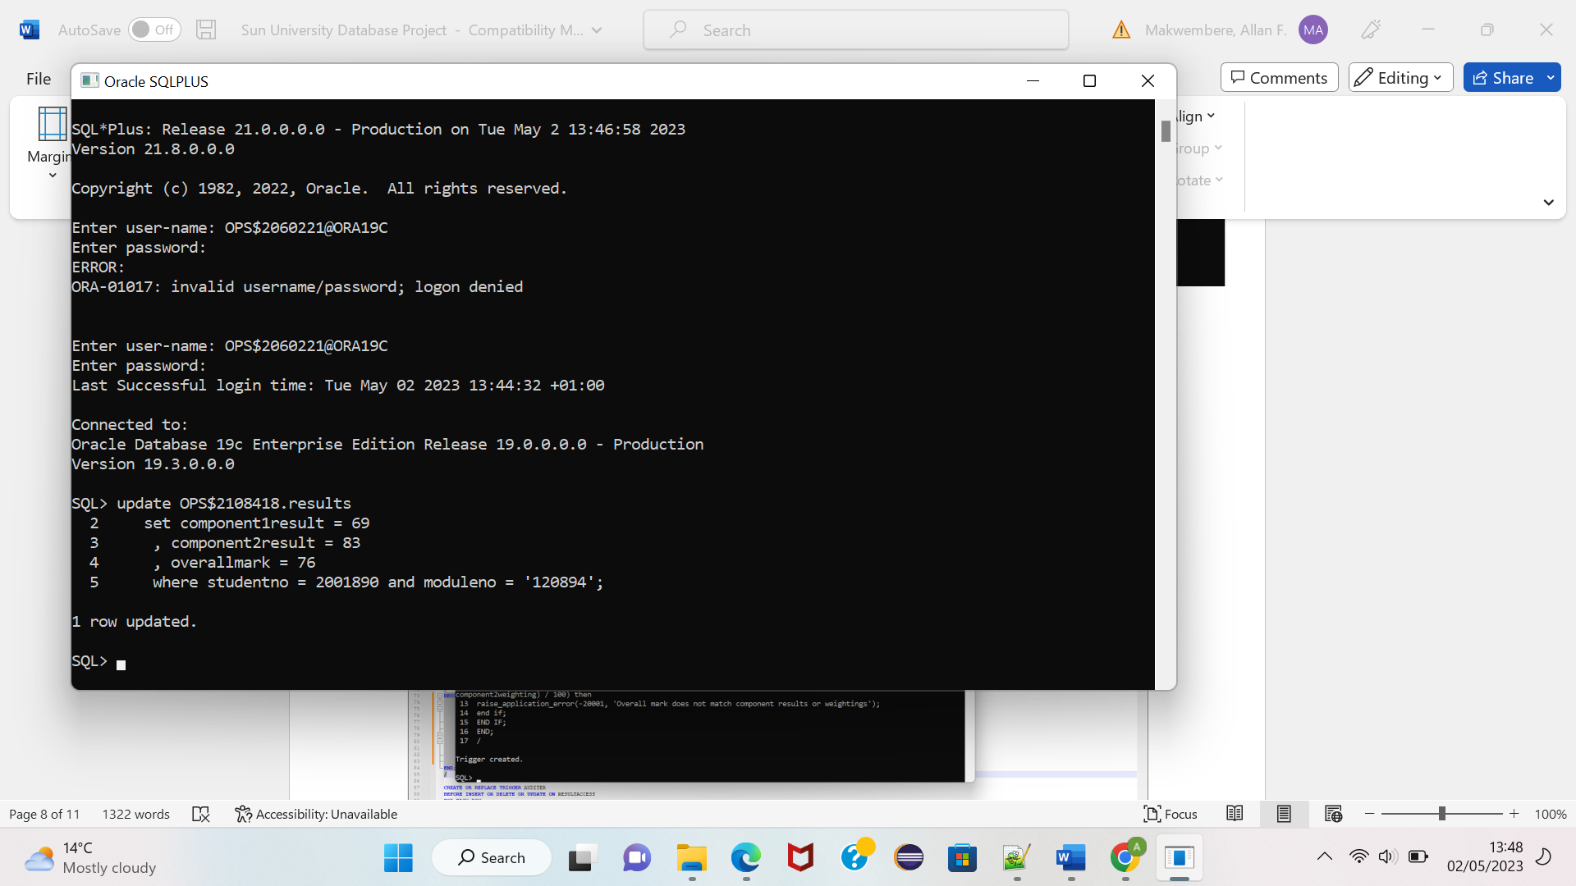u

Following this update, the To_access trigger would fire and store the audit trail within the audit table as shown in the last row of the table below:

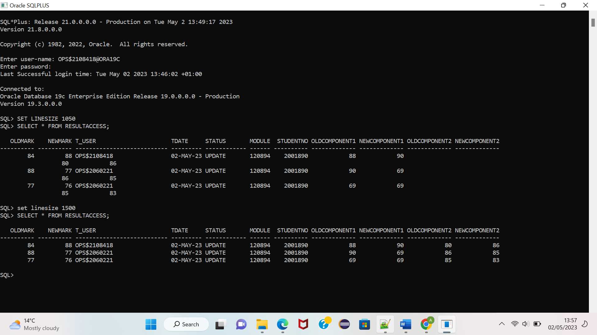

But the above trigger only keeps an audit trail but does not ensure that data is in the correct format. An assumption we made in the beginning specified the following:

* *Overall mark requires a trigger that checks that the mark is correct against the weightings and results of the components.*

To ensure that the overall mark is consistent according to the weightings, I created the trigger below.

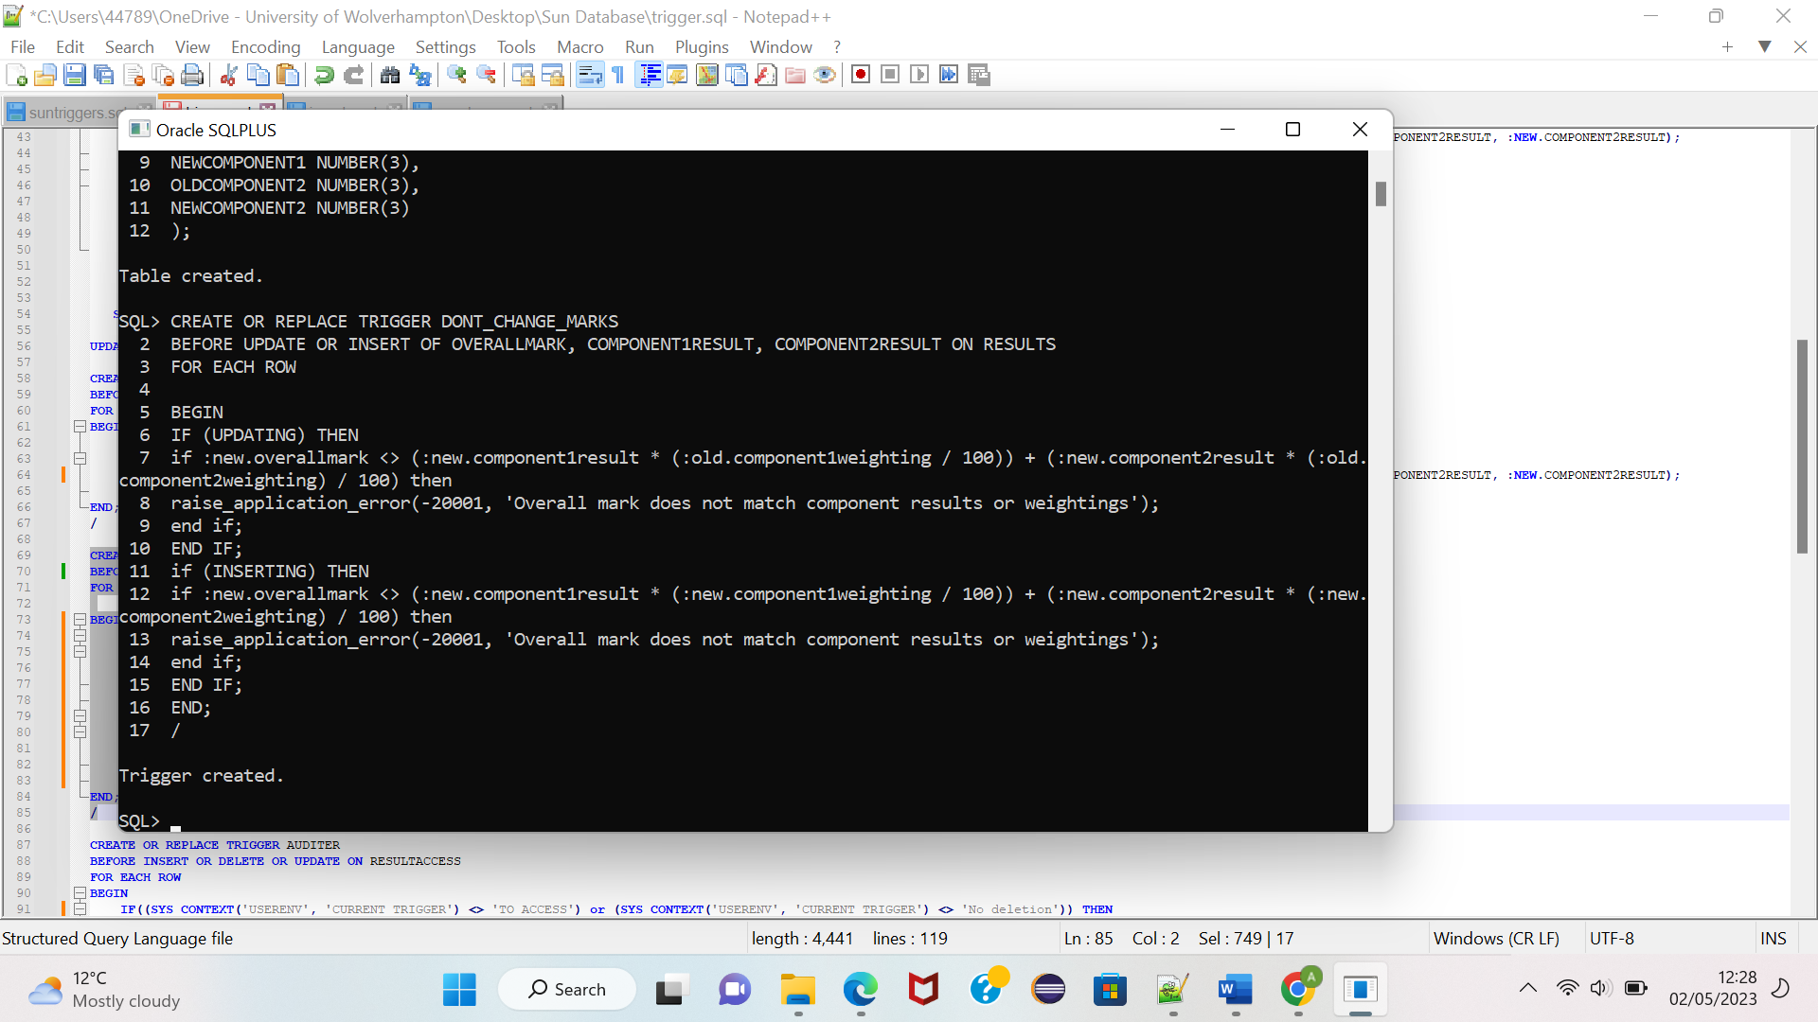

The above trigger ensures that any changes that are made do not result in the overallmark losing its consistency according to the specified weightings. The trigger would be fired for every update done on the marks and for every insertion done in the results table.

If an update does not maintain consistency, an error message will be generated as shown below:

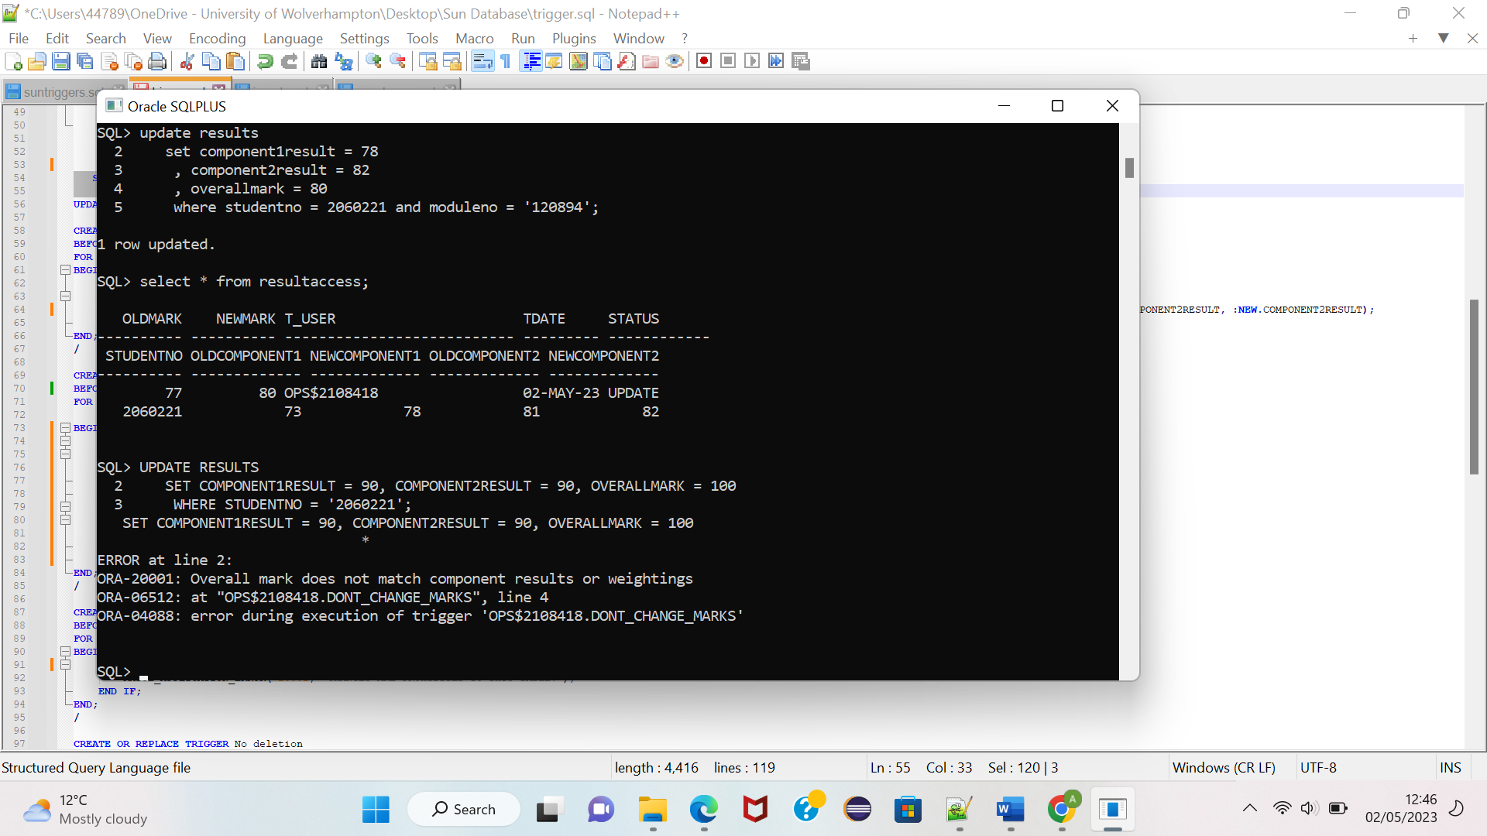

Likewise, if any insertion leads to inconsistent marks that violate the defined weightings, the same error is generated as shown below:

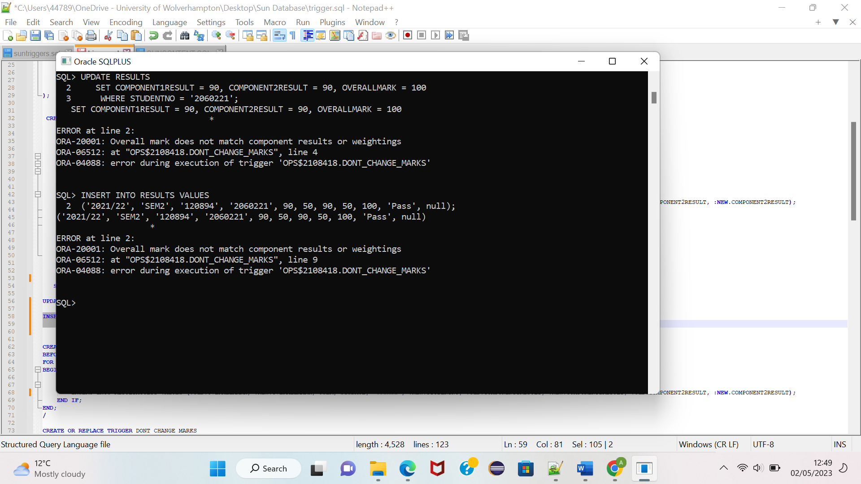

# Delete

A separate trigger has been put in place to monitor deletions that can be initiated by users within the database. If left unchecked these could lead to permanent data losses. So, within the trigger syntax I made sure that only one account or user is allowed to make deletions. $OPS2108418. Any other account would generate an error. Regarding the one user allowed to delete data, the trigger is also linked to the audit table and would therefore store the deleted copy as an audit trail.

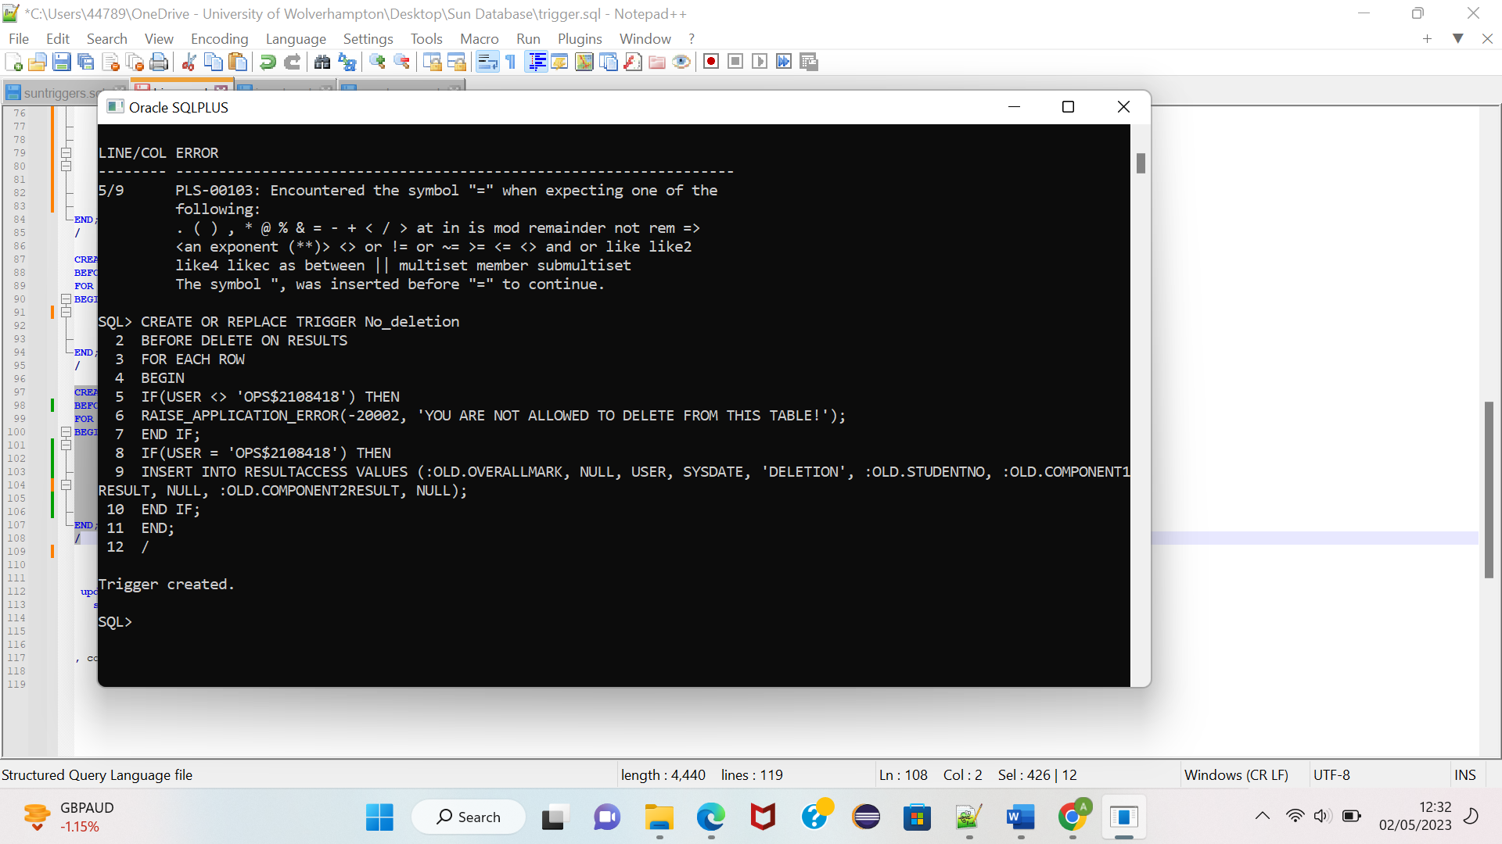

If any user that is not ops$2108418 attempts to delete from the results table, an error message is generated as shown below:

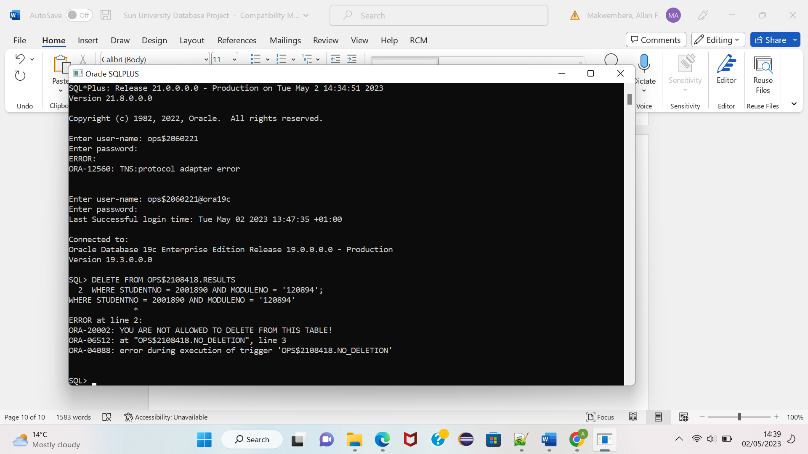

If ops$2108418 deletes from the results table, the old data is stored in resultaccess as an audit trail as shown in the last row of the table below:

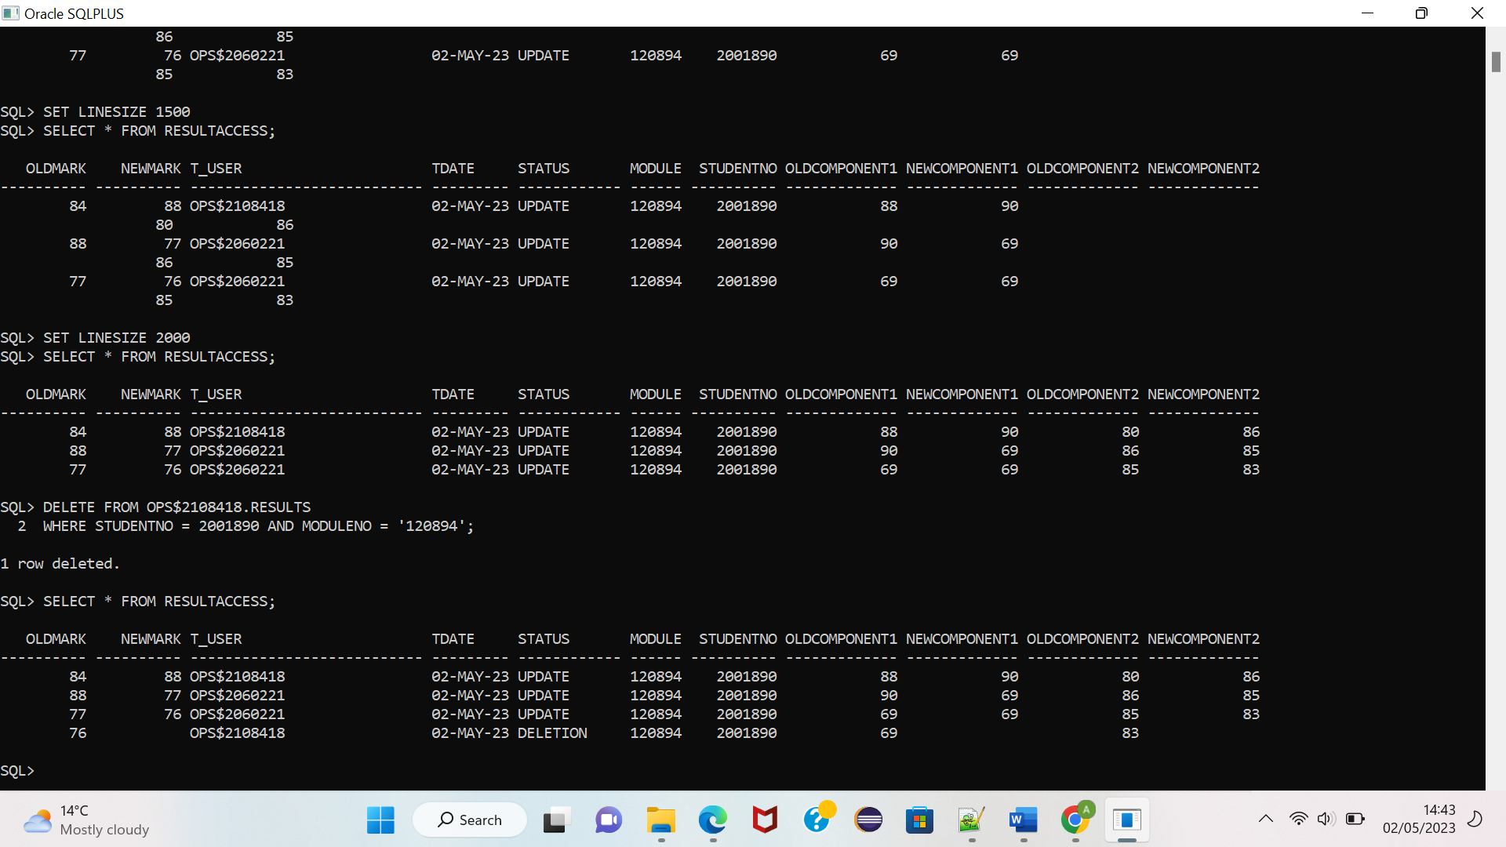

**SQL**

**(FOR TABLE RESULTACCESS):**

CREATE TABLE RESULTACCESS(

OLDMARK NUMBER(3),

NEWMARK NUMBER(3),

T_USER VARCHAR(27),

TDATE DATE,

STATUS VARCHAR(12),

moduleno varchar2(6),

STUDENTNO NUMBER(7),

OLDCOMPONENT1 NUMBER(3),

NEWCOMPONENT1 NUMBER(3),

OLDCOMPONENT2 NUMBER(3),

NEWCOMPONENT2 NUMBER(3)

);

**FOR TRIGGER TO_ACCESS:**

CREATE OR REPLACE TRIGGER TO_ACCESS

BEFORE UPDATE OF OVERALLMARK, COMPONENT1RESULT, COMPONENT2RESULT ON RESULTS

FOR EACH ROW

BEGIN

IF (:OLD.OVERALLMARK <> :NEW.OVERALLMARK) THEN

INSERT INTO RESULTACCESS VALUES (:OLD.OVERALLMARK, :NEW.OVERALLMARK, USER, SYSDATE, 'UPDATE', :NEW.moduleno, :NEW.STUDENTNO, :OLD.COMPONENT1RESULT, :NEW.COMPONENT1RESULT, :OLD.COMPONENT2RESULT, :NEW.COMPONENT2RESULT);

END IF;

END;

**/**

**FOR TRIGGER NO_DELETION:**

CREATE OR REPLACE TRIGGER No_deletion

BEFORE DELETE ON RESULTS

FOR EACH ROW

BEGIN

IF(USER <> 'OPS$2108418') THEN

RAISE_APPLICATION_ERROR(-20002, 'YOU ARE NOT ALLOWED TO DELETE FROM THIS TABLE!');

END IF;

IF(USER = 'OPS$2108418') THEN

INSERT INTO RESULTACCESS VALUES (:OLD.OVERALLMARK, NULL, USER, SYSDATE, 'DELETION', :OLD.moduleno, :OLD.STUDENTNO, :OLD.COMPONENT1RESULT, NULL, :OLD.COMPONENT2RESULT, NULL);

END IF;

END;

/

**FOR TRIGGER DONT_CHANGE_MARKS:**

CREATE OR REPLACE TRIGGER DONT_CHANGE_MARKS

BEFORE UPDATE OR INSERT OF OVERALLMARK, COMPONENT1RESULT, COMPONENT2RESULT ON RESULTS

FOR EACH ROW

BEGIN

IF (UPDATING) THEN

if :new.overallmark <> (:new.component1result * (:old.component1weighting / 100)) + (:new.component2result * (:old.component2weighting) / 100) then

raise_application_error(-20001, 'Overall mark does not match component results or weighting');

end if;

END IF;

if (INSERTING) THEN

if :new.overallmark <> (:new.component1result * (:new.component1weighting / 100)) + (:new.component2result * (:new.component2weighting) / 100) then

raise_application_error(-20001, 'Overall mark does not match component results or weighting');

end if;

END IF;

END;

/

b. Briefly discuss what issues can arise from such an audit trigger in a live  
system and suggest what other methods could be used for auditing  
purposes.

The triggers we have put in place serve the primary function of monitoring what authorised and unauthorised users are doing to the database. In some cases, it also bars them from performing certain actions, like for instance, our No_deletion trigger. However, a lot of issues can arise from such an audit trigger particularly in a live system.

One major concern is the performance drawback that can likely be encountered in a live system. Now we are merely using test data that is low in cardinality and velocity. However, in a busy environment that has multiple online transactions that may be running concurrently, the triggers would cause slow response times due to more processing power being needed by the server leading to significant scalability issues.

[1]Whilst Oracle triggers can monitor varied DML activities, monitoring on SELECT queries can be expensive and uncertain. This is because the select query often returns large volumes of data which can consume a large amount of storage space when trying to put the information as an audit trail.

Triggers also do not allow for the capturing of the statement executed and the result set from the query. Whilst they can be tweaked to capture user information, date, and certain changes, they will not be able to capture the actual query statement, for instance a SELECT statement generating a result set. It becomes difficult to generate the query again later.

Triggers are also incapable of producing user defined alert actions besides their use in creating an audit trail in an audit table. This would limit our understanding of malicious activity within the database where we could have gotten an alert like an email to warn us of unauthorised procedures.

[2]To go around the limitations of triggers in an auditing environment we can make use of fine-grained auditing, which provides refined auditing mechanisms that undo the weaknesses of the triggers.

*[2]Its audit trail provides a fixed set of facts that monitor privileges, object access, or (optionally) SQL usage, including information about the environment or query results.* This means that unlike triggers, more detailed information is captured like the executed SQL statement, the SQL statement user, result set returned and the time. This would allow for better forensic analysis.

*[2]Triggers incur a PL/SQL process call for every row processed and create an audit record only when a relevant column is changed by a DML statement*. This means they incur significant performance costs as they will execute for every call even when no changes are made. Fine-grained auditing, however, does not incur such costs, as it only audits once for every policy. This makes fine-grained auditing a lot more flexible as it can audit specific columns based on criteria such as DML statement types and selection criteria. This allows it to audit only the relevant changes instead of every row.

Fine-grained auditing addresses these needs, taking you beyond standard auditing and enabling you to minimize false or unhelpful audits by specifying more detailed audit conditions.

[2]Triggers cannot monitor the activity of another instead-of trigger on the same object. Whereas fine-grained auditing can monitor the changes made by triggers allowing for greater visibility into database activity.

Besides Fine-grained auditing we can also make use of third-party auditing tools which can provide for advanced auditing capabilities like real-time alerting, anomaly detection, and forensic analysis. One such example is [3]IBM GUARDIUM. It provides protection to structured and unstructured data in databases with a scalable platform that enables continuous monitoring of structured and unstructured data traffic. With also the ability to enforce policies for sensitive data access.

[3][4]Another way is to utilize the built-in auditing features provided within the database like standard oracle auditing. This can be more specific and consume fewer system resources as the system user has more control on what needs to be audited compared to triggers which can fire independenty.

# DATA WAREHOUSING

A)

SQL:

Create TABLE HESA_students (

category_marker VARCHAR (32),

category VARCHAR (32),

first_year_marker VARCHAR (32),

mode_of_study VARCHAR (32),

level_of_study varchar(32),

country_of_HE_PROVIDER VARCHAR (32),

academic_year VARCHAR (32),

student_numbers NUMBER (32),

percentages VARCHAR (32)

)

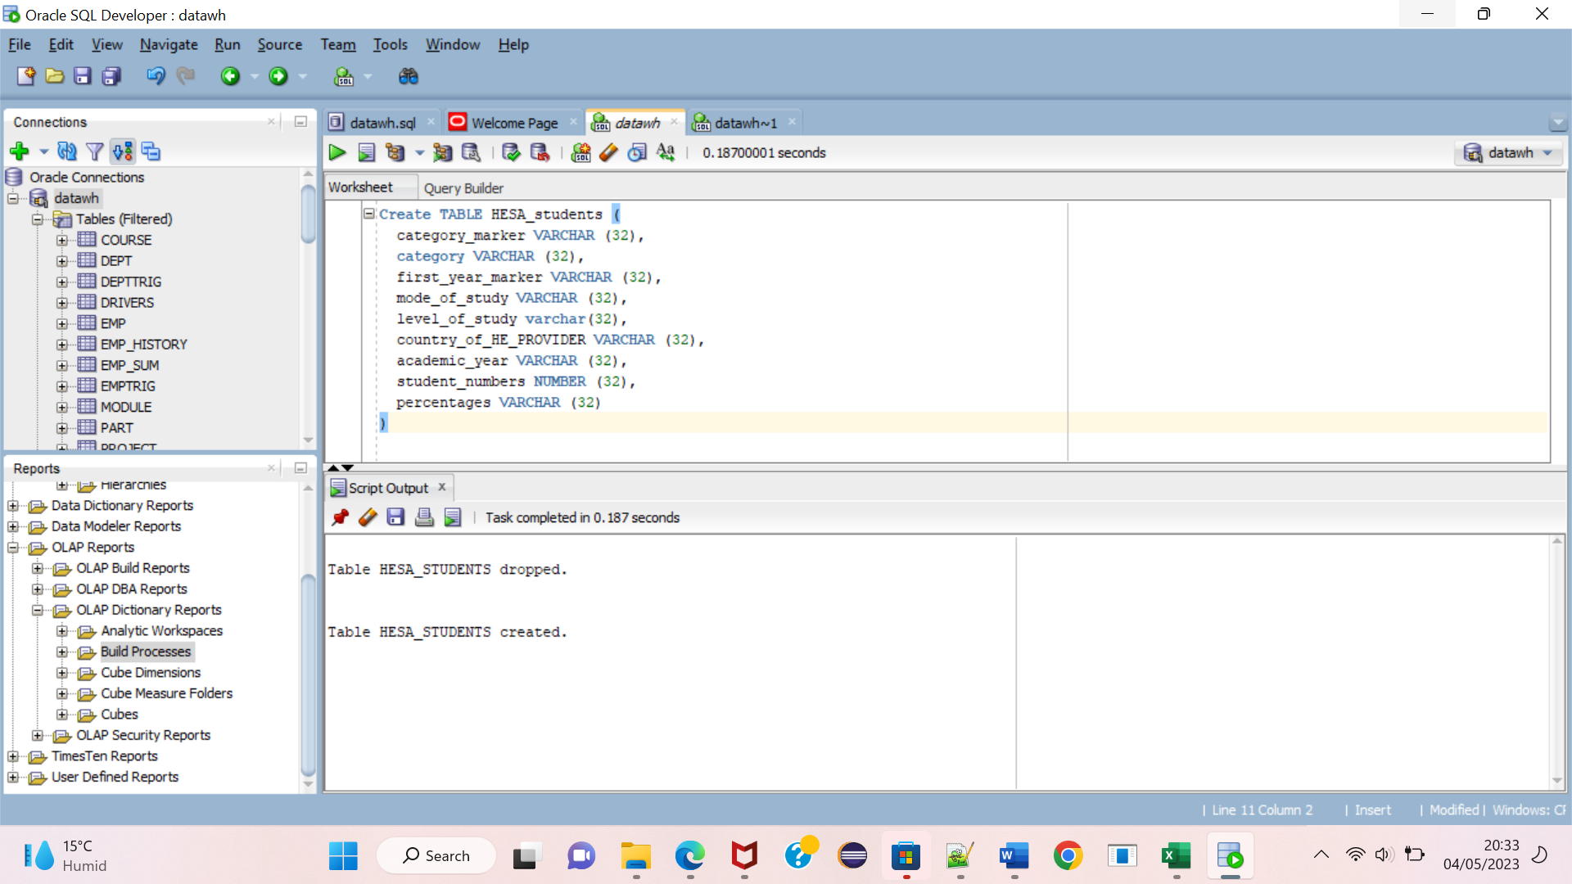

**B)** 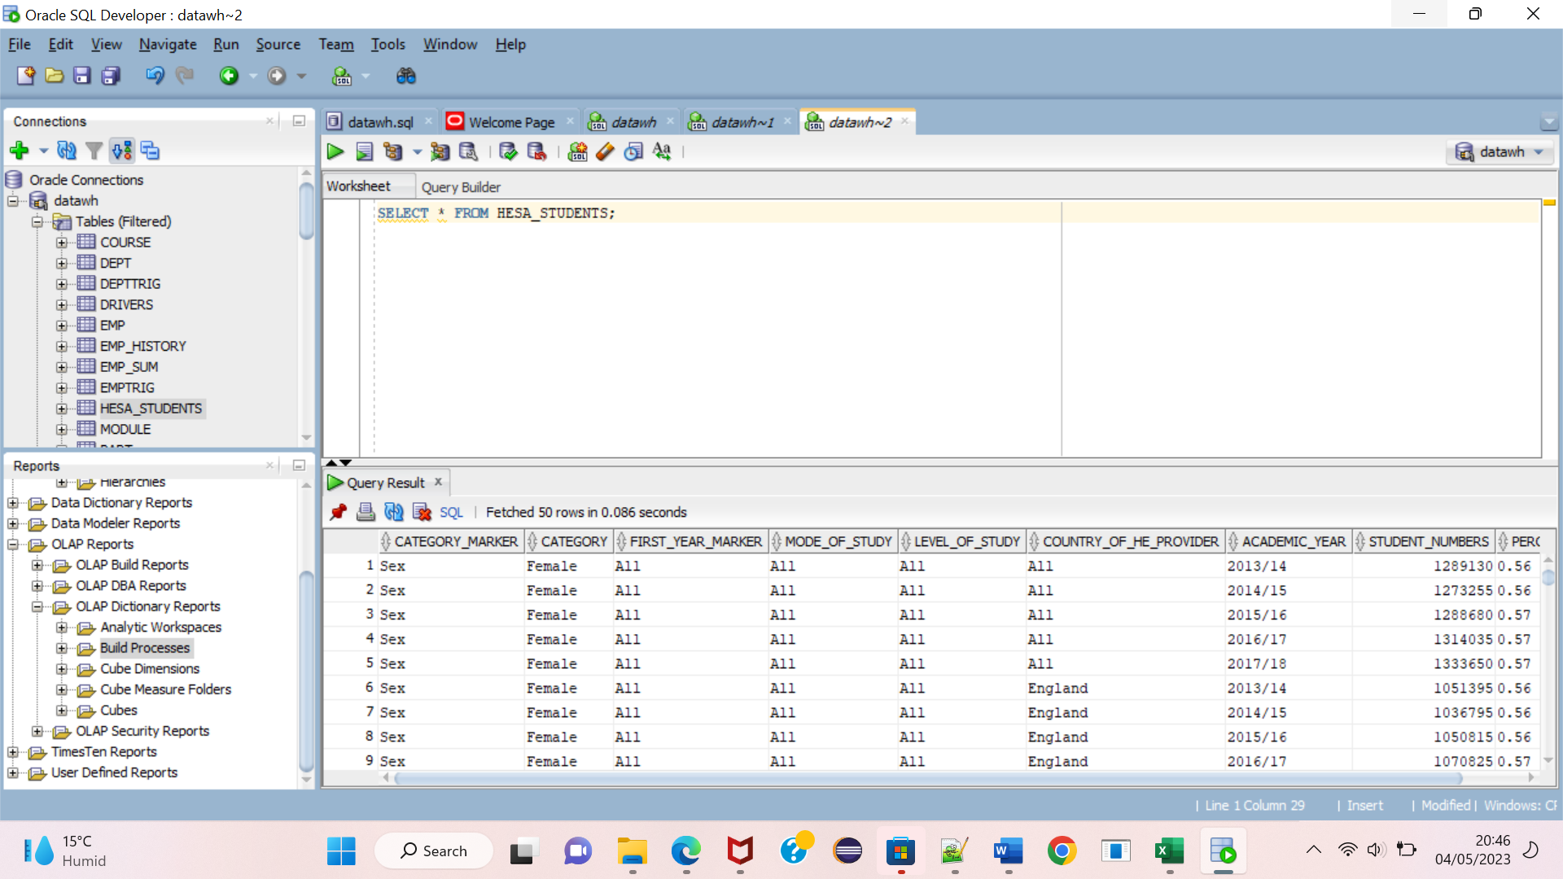

1. Briefly explain what type of queries would be used in an Online Analytical  
   Processing system (OLAP), compared to an Online Transaction Processing  
   (OLTP) system.

OLTP specializes in real-time execution of transactions whilst doing so in as little time as possible. The type of queries involved are “[4]simple and typically involve one or a few database records”. Their tasks can be retrieving or updating individual records. Examples of such queries can be looking up the current average selling price of products in the manufacturing category. Or the address of a customer and maybe the status of their payment.

OLAP on the other hand is mainly functional in a data warehouse for performing multidimensional analysis of large volumes of data. OLAP therefore, extracts and processes from [6]“multiple relational data sets and reorganizes it into a multidimensional format that enables very fast processing and very insightful analysis”. OLAP queries are therefore complex and involve very large data sets. These queries often involve aggregations and calculations that support business decisions. OLAP query examples can be finding the total costs of a product in the Southern region. Or finding the revenue trends in the previous six years. Maybe finding the product showing the most growth over the last quarter.

d. Using the data imported in part b, devise 2 queries that would be suitable  
for a Data Warehouse storing student statistical data.

First Query:

SQL:

SELECT distinct

Mode_of_study,

SUBSTR(ACADEMIC_YEAR, 1, 4),

MODE_OF_STUDY,

SUM(STUDENT_NUMBERS) OVER (PARTITION BY ACADEMIC_YEAR, MODE_OF_STUDY) AS TOTAL_PER_YEAR_OF_STUDY,

SUM(STUDENT_NUMBERS) OVER (PARTITION BY ACADEMIC_YEAR) AS TOTAL_IN_YEAR,

SUM(STUDENT_NUMBERS) OVER (PARTITION BY MODE_OF_STUDY) AS TOTAL_PER_MODE,

(SUM(STUDENT_NUMBERS) OVER (PARTITION BY MODE_OF_STUDY) / SUM(STUDENT_NUMBERS) OVER (PARTITION BY ACADEMIC_YEAR ) * 100) AS PERCENTAGE

FROM HESA_STUDENTS

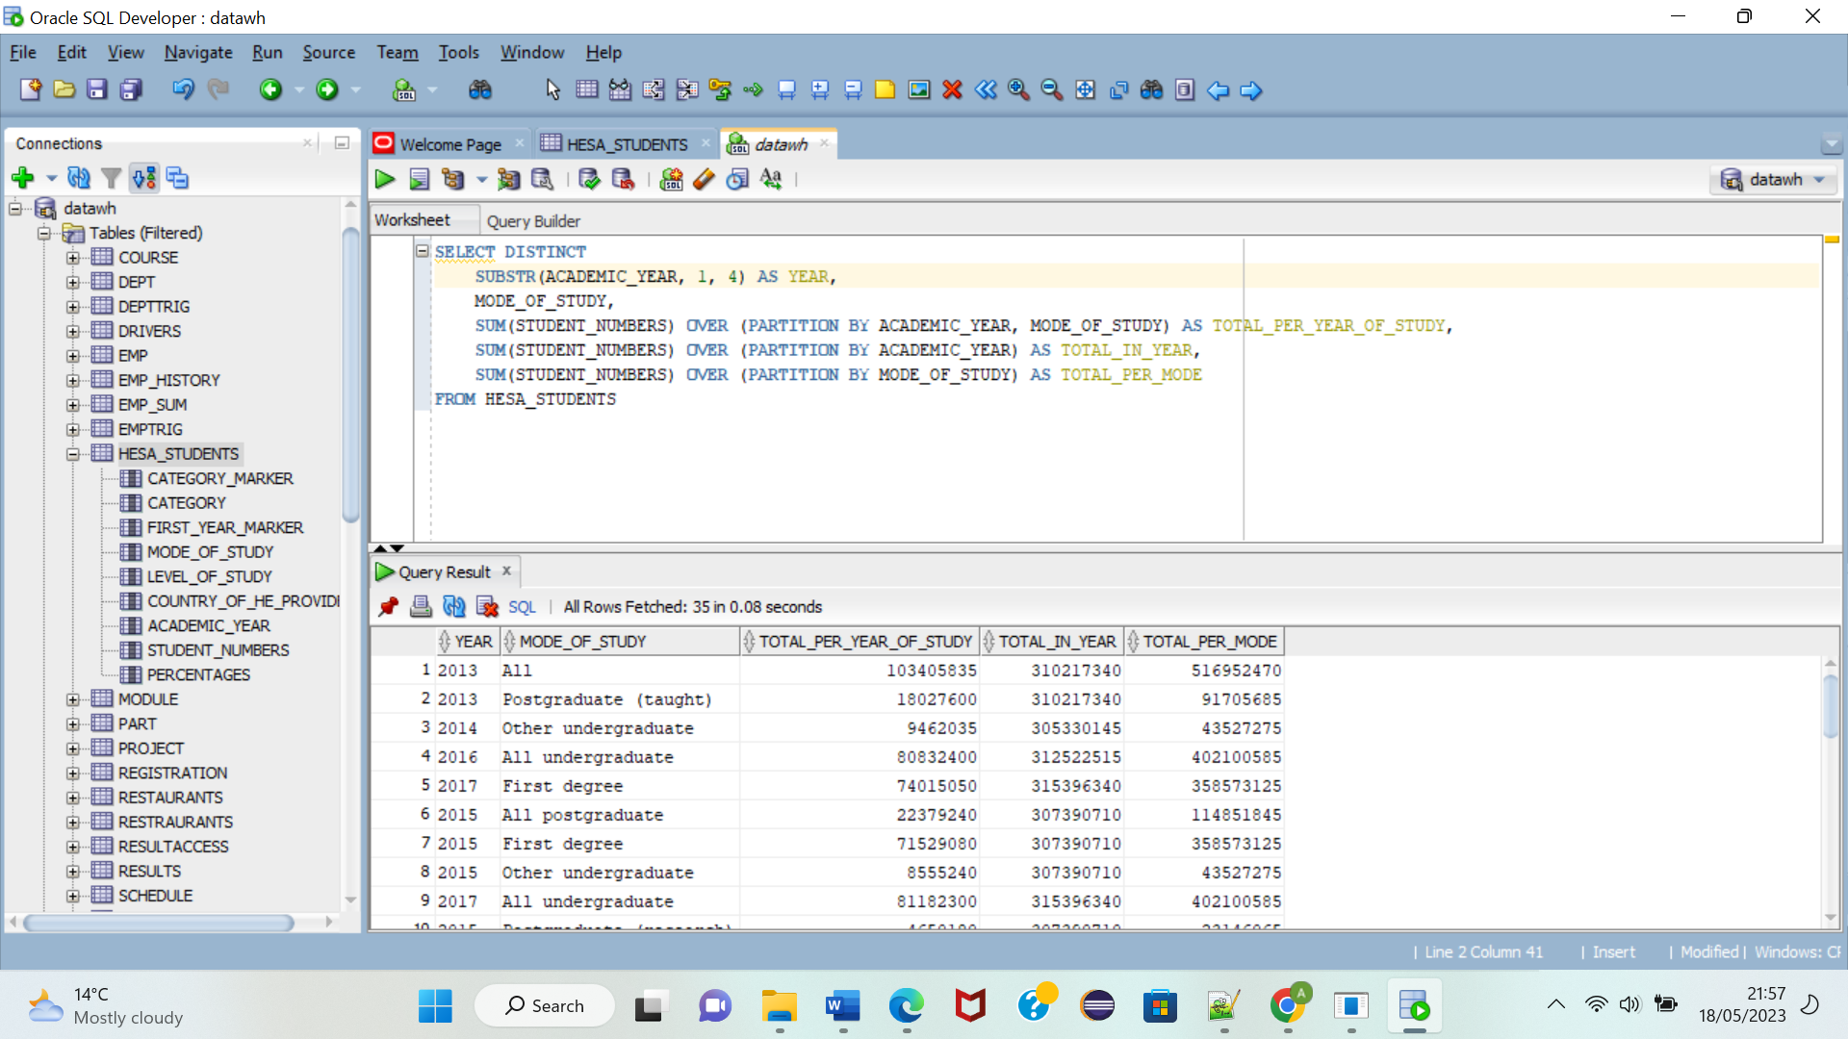

**The above query selects or retrieves the total number of students enrolled in each category (e.g., undergraduate, postgraduate) for each academic year without any duplicates.**

**Second Query**

**SQL:**

SELECT MODE_OF_STUDY, COUNTRY_OF_HE_PROVIDER, ROUND (AVG(STUDENT_NUMBERS)) AS AVG_STUDENT_NUMBERS,

LAG (ROUND (AVG(STUDENT_NUMBERS))) OVER (ORDER BY MODE_OF_STUDY, COUNTRY_OF_HE_PROVIDER) AS LAG_AVERAGE

FROM HESA_STUDENTS

GROUP BY ROLLUSP (MODE_OF_STUDY, COUNTRY_OF_HE_PROVIDER)

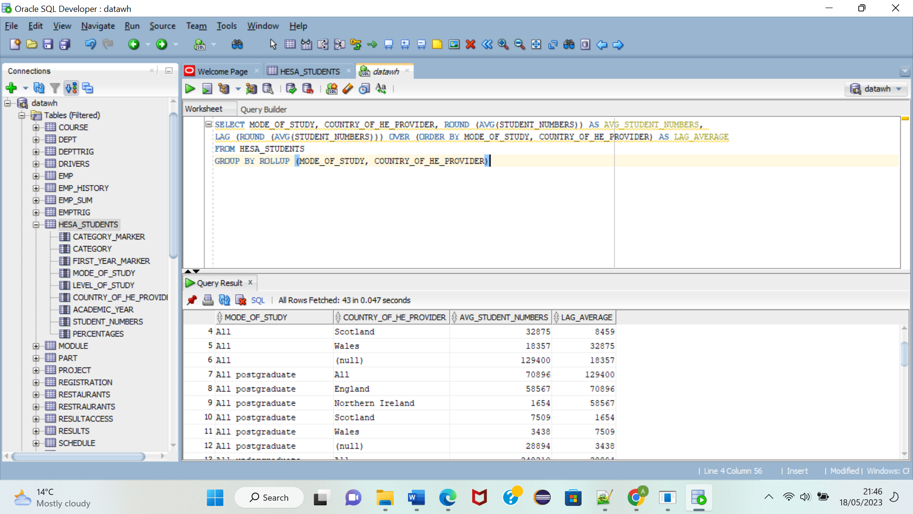

**The above query represents the combination of mode_of_study and country_of_he_provider and returns the average number of students that meet the criteria of the two columns. The ROLLUP function generates the subtotal and grand total rows for the average values at different levels of grouping.**

REFERENCES

[1] [Configuring and Administering Auditing (oracle.com)](https://docs.oracle.com/cd/B19306_01/network.102/b14266/cfgaudit.htm#i1007238) : Using triggers

[2] [Configuring and Administering Auditing (oracle.com)](https://docs.oracle.com/cd/B19306_01/network.102/b14266/cfgaudit.htm#i1009642): Fine-Grained Auditing

[3][IBM Guardium - IBM Documentation](https://www.ibm.com/docs/en/guardium/11.3?topic=overview-guardium): Third-party auditing: IBM

[4] [Database Auditing: Security Considerations (oracle.com)](https://docs.oracle.com/cd/B19306_01/network.102/b14266/auditing.htm#i1008289)

[5] [What is OLTP? | IBM](https://www.ibm.com/topics/oltp#:~:text=OLTP%20queries%20are%20simple%20and,are%20orders%20of%20magnitude%20slower.)

[6] [What is OLAP? | IBM](https://www.ibm.com/topics/olap)

# PEER REVIEW

The database sections were done by both of us.

Analysis- Done by Allan F Makwembere

1. Table creation and test data- Done by Allan
2. Test Data - Done by Abdulgaffar
3. SQL querries- The first 5 and the very last one done by Allan. The Three custom ones done by Abdulgaffar
4. View Definition and Testing- Done by both of us
5. Audit Trigger and Discussion- Done by both Allan.
6. Data Warehousing- Done by Abdulgaffar and some by Allan F Makwembere

Abdul signature(FULLNAME): ABDULGAFFAR YAHAYA IBRAHIM

Allan signature(FULLNAME): ALLAN FARAI MAKWEMBERE